
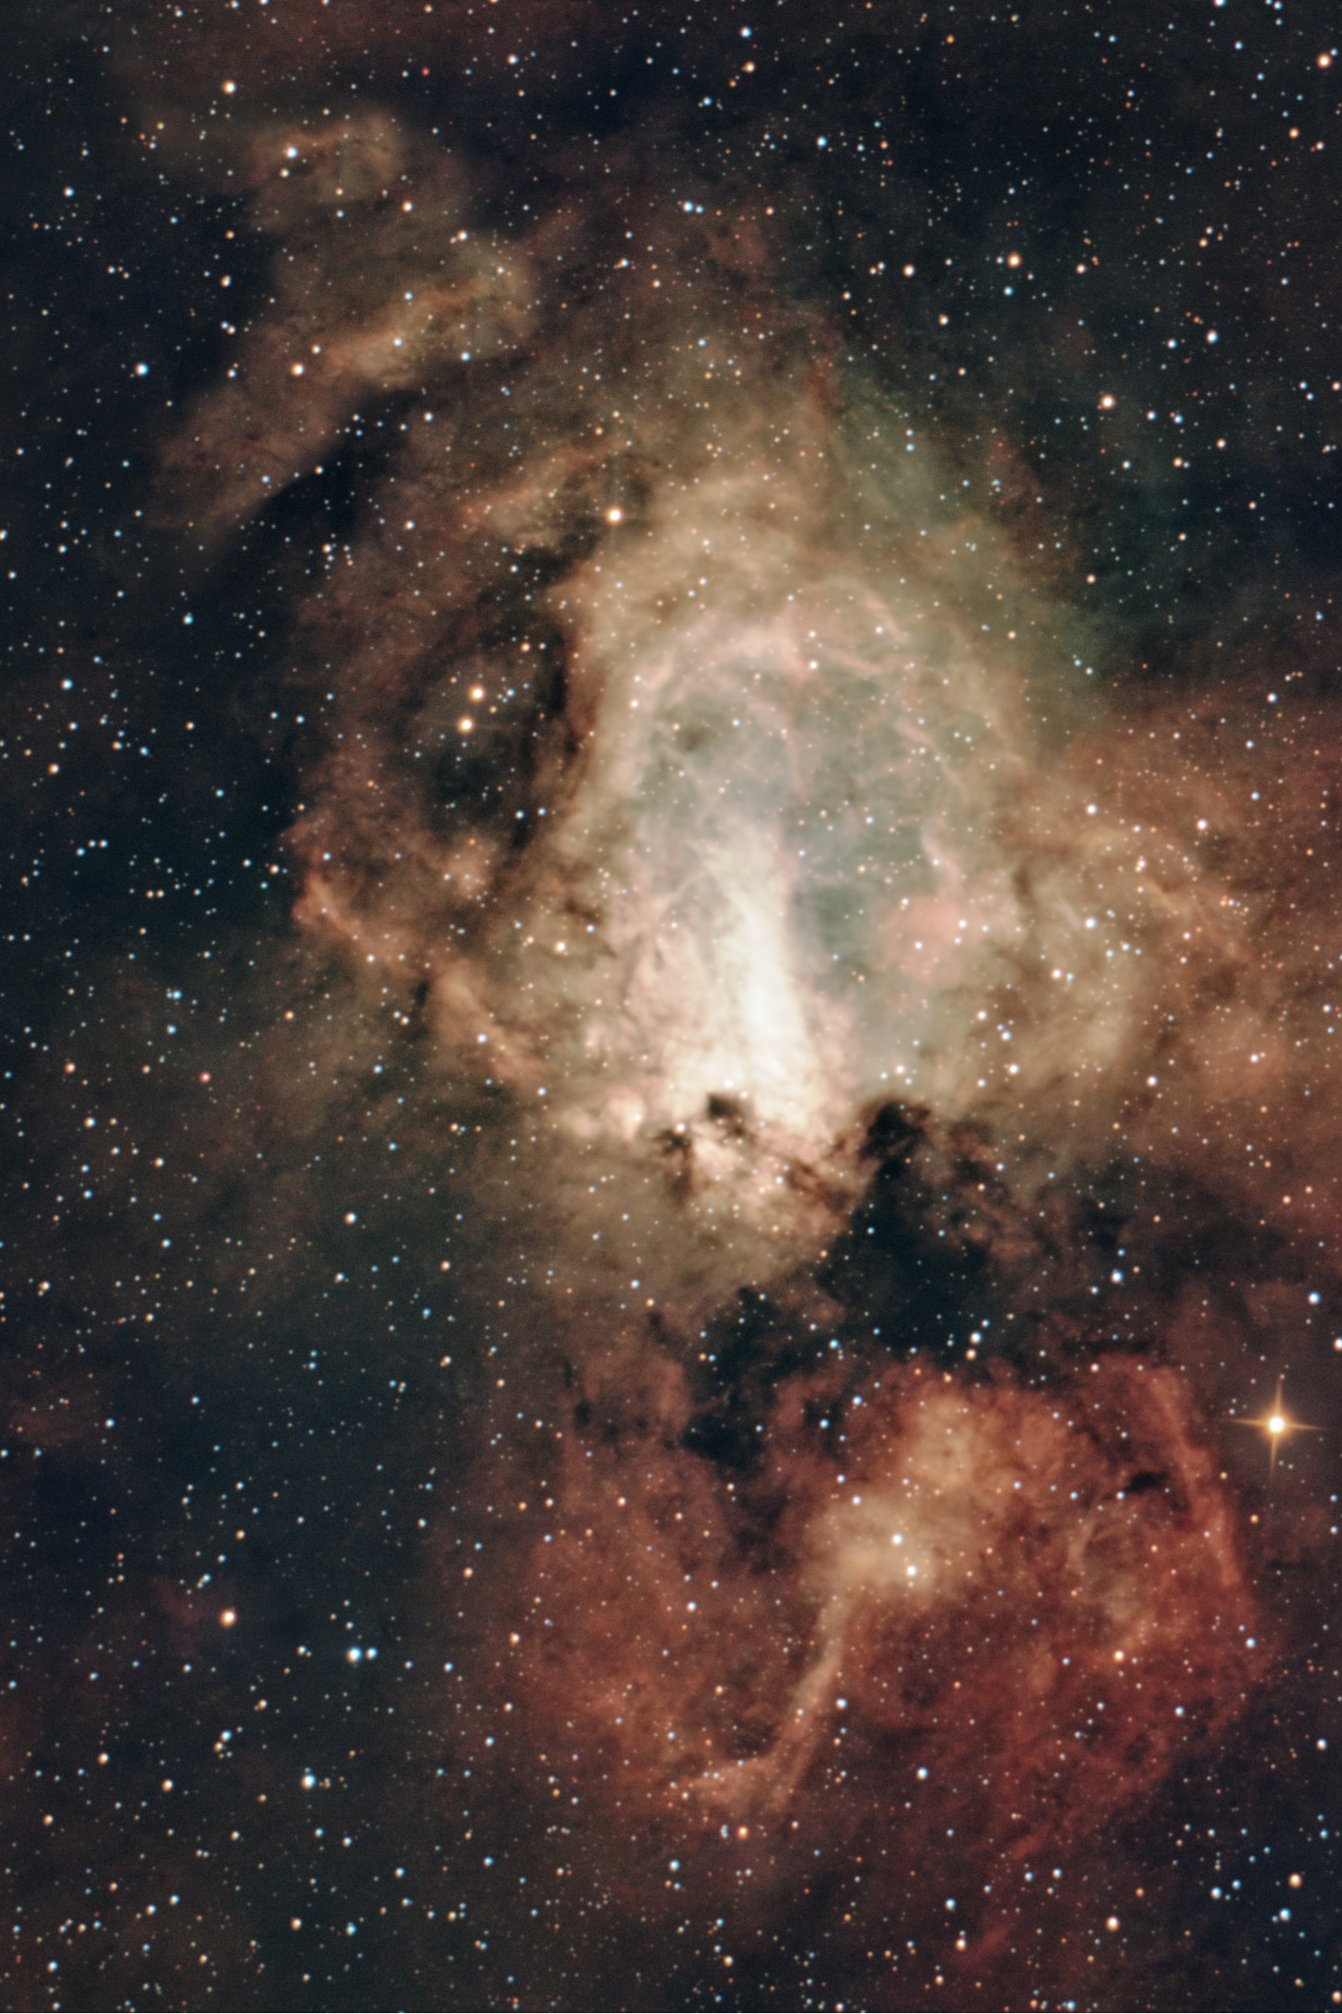
Astrophotography is not just about taking pictures,
but it consists in revealing what our eyes cannot see.
Astrophotographic processing
with
Pixinsight

M 17 - The Omega Nebula
FOREWORD 5
CAPTURE ASTRONOMICAL IMAGES 5
THE IMAGES OF THE OBJECT, COMMONLY CALLED LIGHT 6
Setting the GAIN 6
Unity Gain 6
Using filters 7
CALIBRATION FILE (Keep in separate folders for each shot type) 7
➢ BIAS 7
➢ DARK 7
➢ FLAT 8
➢ DARKFLAT 9
IMAGE PROCESSING IN PIXINSIGHT 9
FRAME SELECTION AND INTEGRATION 9
2) IL WEIGHTED BATCH PREPROCESSING 11
2a) INTEGRATION OF LIGHTS TAKEN ON DIFFERENT DATES using WBPP (Weighted Batch Pre Processing) 11
2b) THE WBPP PROCESS 11
2c) CRITERIA FOR SELECTING LIGHT 15
AESTHETIC IMAGE TREATMENT 16
3) LINEAR PHASE PROCESSING 16
4) IMPOSTARE L'RGB WORKING SPACE A 1:1:1 17
PREPARING IMAGES TO BE MERGED IN THE NEXT STEPS 17
5) IMAGE ROTATION 17
6) ALIGN IMAGES 17
7) DYNAMIC CROP 17
8) IMAGE SOLVER OF THE IMAGE 18
9) FIRST NOISE REDUCTION 18
10) GRADIENT ELIMINATION 19
13) GRADIENT CORRECTION 19
14) ABE GRADIENTS 20
15) BACKGROUND ADJUSTMENT 20
16) BACKGROUND ADJUSTMENT by automated method 21
17) GRADIENT ELIMINATION with GRAXPERT 22
18) COLOR CALIBRATION 22
19) SYNTHETIC FLAT 23
20) BRINGING COLOR CHANNELS TOGETHER 23
21) HDR COMPOSITION OPTION to merge different images e.g. with different exposure times 23
22) NOISE REDUCTION 24
20) IMAGE PROCESSING IN HUBBLE PALETTE 28
PROCESSING FOR STARS AND STELLAR SUBJECTS 28
IMAGE STRETCHING 28
21) HISTOGRAM CORRECTION 28
23) STELLAR DETAIL RECOVERY 28
24) STAR MASKING - This processing part is called Star Mask 29
24a) Procedure 29
25) IMPROVING STAR COLOR 29
26) DARKENING THE SKY BACKGROUND 30
PROCESSING FOR CLOUDS 30
27) MASKING STARS 30
28) CREATE LUMINANCE MASK 30
29) CHANGING THE HISTOGRAM OF THE LUMINANCE IMAGE 30
30) CREATE A BLACK IMAGE to possibly blacken areas on masks 31
31) DELETE any SPOTS if present on the part of the deep sky 31
32) APPLY THE MASK ON THE IMAGE 31
33) CREATE A RANGE MASK where you can then improve the sharpness 31
34) DECONVOLUTION 31
35) IMAGE STRETCHING 32
35a) MULTISCALE ADAPTIVE STRETCH 32
35b) GHS (GeneralizedHyperbolicStretch) Manual method 32
36) According to any GRADIENT CORRECTION 34
COSMETIC IMAGE PROCESSING 34
PROCESSING ON THE NEBULA 34
37) HDR TRANSFORMATION of the Nebula 34
38) SECOND NOISE REDUCTION of chroma on deep sky in linear 35
39) INCREASE CONTRAST IN DARK AREAS 35
40) A SLIGHT HDR always to accentuate the gas areas 35
41) IMPROVE NEBULA COLOR CURVES 35
42) IMPROVE CONTRASTS of the light areas of the nebula 35
43) DARKEN THE BACKGROUND OF THE SKY if necessary 36
44) ADJUSTING THE COLORS of the nebula 36
45) CORRECTING NEBULA COLORS 36
46) ALTERNATIVA: USARE LO SCRIPT SELECTIVE COLOR CORRECTION 37
47) REMOVE COLOR DOMINANCE 37
48) INCREASE CONTRAST IN DARK AREAS 37
49) IMPROVING AREA TOO LIGHT – BURNT 37
50) BRINGING NEBULA AND STARS TOGETHER 37
51) SLIGHT REDUCTION OF STARS 37
52) DARKEN THE BACKGROUND AGAIN 37
53) LAST POSSIBLE NOISE REDUCTION 38
54) COPYRIGHT 38
55) IDENTIFY STARS AND NEBULAE with image annotation 38
57) SAVE IMAGE 39
58) INSERT A LOGO OR GRAPHIC WITH PHOTOSHOP 39
59) INSERT A LOGO OR GRAPHIC WITH LIGHTROOM 39
TECHNIQUES FOR WORKING WITH MOSAICS or/and DIFFERENT FILTERS 40
01. IL SUBFRAME SELECTOR; F/P 40
02. IL WEIGHTED BATCH PREPROCESSING; F/P 41
03. IL WEIGHTED BATCH PREPROCESSING; P 42
04. LINEAR PHASE PROCESSING; F/P 42
05. EQUALIZE LUMINANCE; F/P 42
06. GRADIENT ELIMINATION through Gradient Correction; F/P 42
07. COLOR CALIBRATION; F/P 42
08. NOISE REDUCTION; F/P 42
09. EQUALIZE THE IMAGES OF THE PANELS (still in linear phase) ; F/P 42
10. ALIGN THE PANELS TO MAKE THE MOSAIC: P 43
11. IMAGE STRATCHING; F/P 43
12. FUSE THE PANELS TOGETHER: P 43
13. DYNAMIC CROP of the resulting panel; P 43
14. IMAGE SOLVER OF THE IMAGE; F/P 43
15. AESTHETIC PROCESSING; F/P 43
16. MASKING STARS; F/P 43
17. ELIMINATE any STAINS if present on the part of the deep sky; F/P 43
18. Deconvolution of the Nebula; F/P 43
19. LOCAL HISTOGRAM EQUALIZATION; F/P 44
20. A SLIGHT HDR again to accentuate the gas areas with the EZ HDR script; F/P 44
21. POSSIBLY increase the CONTRAST IN DARK AREAS; F/P 44
22. ADJUSTING THE COLORS of the nebula; F/P 44
23. CORRECTING NEBULA COLORS; F/P 44
24. IMPROVEMENT OF THE AREA TOO LIGHT – BURNED; F/P 44
25. PROCESSING ON THE STARS RGB image; F/P 44
26. DARKEN THE BACKGROUND SKY; F/P 44
27. MERGE B and RGB CHANNELS; F/P 44
28. DARKEN THE BACKGROUND OF THE SKY AGAIN with ArcsinhStretch; F/P 44
29. IDENTIFY STARS AND NEBULAE with annotation on the image; F/P 44
30. EDGE CROPPING using Dynamic Crop process; F/P 44
TENICA DEL CONTINUUM SUBTRACTION 45
Channel extraction 45
Ha and R image processing 46
Now we can continue with Finding a pure Ha that is the Continuum subtraction 47
Finding a pure Ha 47
TECHNIQUES FOR JOINING COLOR CHANNELS 49
1. First method 49
2. Second technique 49
3. Other technique 49
4. Other method 50
5. An additional technique 50
6. The most correct technique 51
7. HDRComposition 51
TECHNIQUE FOR COMET PROCESSING https://www.youtube.com/watch?v=VrdCcL8J8x8 52
NOTE SU PIXINSIGHT 54
External scripts 54
External processes 54
Label laterali Pixinsight 54
LIBRARIES FOR PIXINSIGHT 54
GAIA Bookcase 54
APASS Bookcase 54
MARS (Multiscale All-Sky Reference Survey) 54
CREATE PIXEL_MATH PROCESS 55
HOW TO CREATE LOCAL MASKS WITH PIXINSIGHT 56
Create luminance mask of stars 56
Create a black / white image 56
GAME 57
EXPLANATION OF AESTHETIC DEFECTS 57
CREATE CUSTOM FILTERS FOR SPCC 59
DEFINE THE USE OF CUSTOM FILTERS FOR SPCC 61
MULTICHANNEL RESOURCES 62
ISO to Gain for Cameras 63
Sources and references 63

FOREWORD
This text was created to help me and help me in astrophotographic processing, an activity that at the beginning I found particularly complex, despite the photography experiences I already had. For me it was therefore a growth of experience both in astrophotographic shooting and in subsequent post-production processing. In this growth I have to thank my friend Alberto Airola who with his patience did his utmost in explanations, sometimes even repeating them several times. I hope with this I have always interpreted well what he explained to me or / and read.
This version 06.1 maintains the workflow and setting of the previous version, but corrects some technical formulations that could be interpreted as universal rules. In particular, the sections relating to gain and Unity Gain, calibration with Bias/Dark/Flat, WBPP, Local Normalization, Drizzle, frame selection, RGB Working Space and Continuum Subtraction have been revised.
I take it for granted that everyone already has their own setup aimed at shooting their favorite subjects (videos for shots of the sun, moon and planets, photographs for shots of nebulae, clusters and galaxies) and with it they are already able to capture images of the sky. My main interest is aimed at nebulae, without disdaining some clusters and some galaxies.
I wanted to write this text to give myself a workflow to follow from time to time at least partially. I write "partially" because the post-production flow is a flow subject to considerations on the result you want to obtain, the subject you want to process, the starting images (frames), without forgetting the goodness of the sky on shooting nights, and the setup used in filming.
The program that I prefer to use and that I deal with in this text is Pixinsight, but there are several others that are just as good. This is my choice, but everyone is free to follow other paths such as Siril, Photoshop, etc.
Within Pixinsight, to achieve a certain result, even the processes and scripts are not unique, i.e. to obtain a certain result, everyone is free to choose the one they prefer. Therefore, no two processing flows will ever be the same and with the same frames the same final image will never be obtained, in terms of colours and shades. The sequence of phases may vary depending on the result as post-production progresses, some of them may be carried out before and others after.

In the text I have highlighted in yellow the parts that I want to keep highlighted, or because it is a text that has just been inserted compared to the previous version.
I wrote in "blue – normal" any references to websites
I wrote in "blue – italics" the parts of the text indicating alternative processes or explanations

CAPTURE ASTRONOMICAL IMAGES
There are two key characteristics to be aware of, which derive directly from the nature of astronomical subjects:
- The wavelengths of their light
- The very low brightness
While in the "terrestrial" reality, to which normal photography is addressed, all the colors of the visible spectrum are present (the rainbow to be clear), in space things go differently. There are few colors, but some are special.
In astronomical images we can encounter different sources and types of light: stars, emission nebulae, reflection nebulae, galaxies, star clusters and other celestial objects.
Stars generate light thanks to the thermonuclear fusion process; their colors can be: red, orange, yellow, white, blue.
Even the large "clouds" of luminescent gases, which also form nebulae, emit light (emission nebulae), but not by the same physical process as stars. It is the ionized gases of which they are formed that emit light when they are "stimulated" by the energy of stars. They therefore behave like the neon gas of fluorescent tubes for illumination.
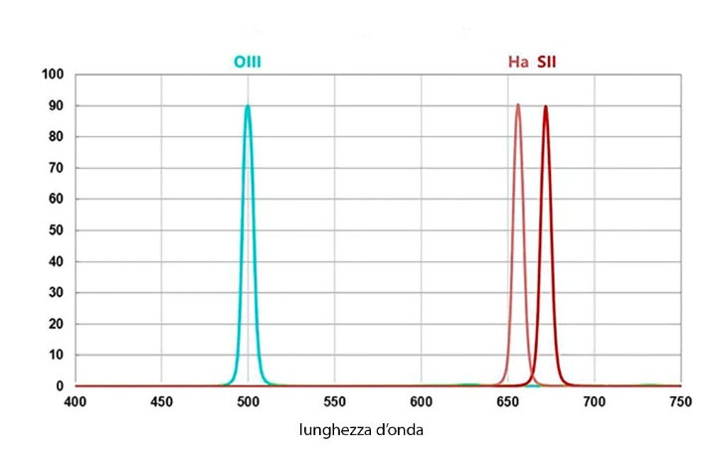
Depending on the type of gas, the color of the light emitted varies.
There are three most common ionized gases:
Alpha hydrogen (Ha) – deep red/orange at 656 nm (approx.)
Oxygen 3 (or OIII – Twice ionized oxygen (O2+)) – blue-green/turquoise at 500 nm
Sulfur 2 (or SII – Sulfur once ionized (S⁺)) – dark red/deep red at 673 nm

Finally, there are reflection nebulae as sources of light in space. They merely reflect and scatter the light of nearby stars, and are white/bluish in color.
Stars and all celestial objects, except for the Sun and Moon, have very weak apparent brightness (due to the great distance) and this is especially true of nebulae, which for me are the most beautiful subjects to photograph.
We know that for low light situations in photography we must have the longest shutter speed possible combined with a high sensitivity (Gain or ISO), but we also know that long shutter speeds generate digital noise.

On our photo, two types of noise are added together:
- The random noise, particularly noticeable when the signal is weak and at certain gain settings, which manifests itself as a sort of colored grain, and the thermal contribution that increases with the duration of the exposure.
- The noise associated with long exposures is related to the dark current of the sensor: during exposure, electrons are thermally generated even in the absence of light. As the temperature and exposure time increase, this contribution increases and can make systematic defects such as hot pixels and amp glow more evident.
The first contribution is countered with a special shooting technique, called stacking, which literally translated means "stacking in a stack". Stacking consists of integrating multiple images of the same subject to obtain a final image with a better signal-to-noise ratio.
The second contribution, linked to the dark current and its systematic components, is instead characterized and corrected in post-production by means of the Dark, i.e. images acquired in the dark with shooting conditions consistent with those of the Light. The cooled astronomical cameras also have a sensor refrigeration system, which serves to reduce the dark current already during the shooting.

THE IMAGES OF THE OBJECT, COMMONLY CALLED LIGHT
The images of the astronomical object are commonly called LIGHT. The exposure must be chosen according to the background sky, the gain, the dynamics of the camera, the filter and the subject, looking for a good compromise between the signal collected and the saturation of the stars or the brightest areas. The AVG-based criterion described below is an empirical method used with specific setups and should not be considered a universal rule.
Example of an ideal AVG calculation:
Made a Bias with 1/1000" 1926 ADU hit.
With the L-Pro (wideband) filter, in my example, I add about 1200–1500 ADUs to 1926 ADUs, resulting in 3100–3400 ADUs as the empirical reference range for that setup.
With a narrowband filter, the background sky is much less bright; therefore the value could also be doubled because the narrow band allows much less light to pass through. However, this is an empirical method because the exposure must still be determined on the basis of the background, the gain, the dynamics of the camera and the subject's signal.

Setting the GAIN
In astrophotography, gain determines how the electronic signal produced by the sensor is converted and amplified into digital data. Increasing the gain can help make faint details more visible, but changing the gain does not increase the number of photons collected or the quantum efficiency of the sensor.
Depending on the camera and the level of gain, read noise can be reduced, but generally increasing the gain also reduces the amount of charge that a pixel can accumulate before saturation (it saturates earlier), with a consequent reduction in the dynamic range. For this reason, the gain must be chosen together with the exposure time (often making it advisable to use shorter exposure times) and the level of the background sky.

Unity Gain
The Unity Gain is the level of gain, specific to each camera, at which nominally a single electron collected from a pixel of the sensor is converted into a unit of the digital value, i.e. 1 ADU.
It is an important benchmark and, for many cameras, represents a particularly balanced level of gain between reducing read noise and maintaining dynamic range.
However, the gain actually used may be different depending on the background sky, the exposure time and the characteristics of the shot.
How it works:
Gain mainly modifies the conversion of the signal into digital values and, depending on the camera, the behavior of read noise and dynamics. It does not increase the intrinsic sensitivity of the sensor, which depends mainly on its quantum efficiency and spectral response.
Gain levels: increasing the gain, with the same electronic signal, increases the separation between digital levels and generally decreases the ability to represent large amounts of charge before saturation. The advantage may be a reduction in read noise, but the actual benefit depends on the camera and the shooting conditions.
The Unity Gain is that specific point that allows you to obtain an excellent compromise between signal and noise. It is a crucial reference point, especially in modern CMOS sensors, where the read noise decreases significantly as the gain increases, with a particularly marked reduction up to this point and subsequently more gradual.
The choice of gain must however be made by evaluating the specific behavior of your camera, the level of brightness of the background sky and the exposure time used, avoiding both unnecessarily reduced dynamics and inconvenient electronic sampling. And this is important in the choice of gain because, if the background sky is with strong light pollution, the pixel quickly accumulates signal even without considering the subject. Therefore, a high gain, associated with long times, can more easily lead to the saturation of stars and bright areas.

Using filters
Depending on the goodness of the sky, the level of light pollution, we may or may not need to use a broadband filter that allows the passage of a wide spectral range by blocking only some selected wavelengths, those of the light emitted by light sources of artificial origin.
If you photograph deep sky subjects: emission nebulae, supernova remnants and planetary nebulae, or if the light pollution is really exaggerated, you will also possibly also use narrowband filters that allow only the light of a certain spectral line to pass through. We will therefore have groups of images made with different sets.
The lights must therefore be grouped by shutter speed and sensitivity; in the case of astronomical cameras also by binning and, if obtained with a cooled camera, by temperature. To obtain good integration, it is preferable to have more frames, a greater number allows better noise reduction and more effective management of anomalous values.

NOTE: When we want to make images of subjects with a wide range of brightness for which we will have burned areas, it is advisable to make short exposures in broadband for the stars and numerous exposures at different exposures in narrow band for the nebula, exposures to be then integrated in HDR to recover the burnt parts.

CALIBRATION FILE (Keep in separate folders for each shot type)
In PixInsight, calibration frames are auxiliary images used to correct instrumental and optical defects in astronomical images before actual processing.
They are therefore used to clean the raw data (light frame) by eliminating electronic noise, vignetting and dust on the sensor or optical train.
The average (or median, in the case of dark and bias) of the calibration frames makes up what is called the master. Each single shot of light must be calibrated, before it is combined, with the relative masters (dark and/or bias, flat). Even the flat fields, which are special images of light, must be calibrated, before being averaged and creating the relative master, with a darkflat frame master or master bias frame. Usually the software used takes care of this intricate intertwining but it is better to be aware of what it will do.

- BIAS
BIAS primarily measure the electronic offset and a portion of the readout behavior at minimum exposure. They can be used in the calibration of Lights and Flats when they are appropriate for the sensor and calibration method used. However, they are not a universal substitute for Darks: a Bias does not contain the same information about the dark current, amp glow and hot pixels as a Dark acquired with the same exposure as the Light.
To perform them, you have to put the cap on the camera, keep the same Gain/ISO sensitivity used for the Lights and set the fastest possible shot. In practice, it is useful to acquire a large enough number of Bias to build a MasterBias with low noise; 50 frames can be a practical reference, while 100–200 are often used when you want to further reduce the noise of the master.

- DARK
Dark frames measure the signal produced by the sensor in the absence of light during an exposure of the same duration as Light. They include the contribution of dark current and systematic components such as hot pixels and amp glow. Dark current decreases with temperature, but its level and importance depend on the sensor and the shooting conditions; for this reason, the usefulness of Dark must be evaluated according to your camera.
The Dark must be performed with the same conditions used to shoot the light, i.e. the same time, the same sensitivity and, very important, with the same temperature, but with the cap on the camera.
If the sensor has temperature control, we can also shoot dark frames calmly at home and create a real library to be renewed, e.g. once a year, thus saving a lot of time. With DSLRs, which do not have sensor temperature control, making dark frames is difficult and creating a library impossible.
Each dark frame contains: unwanted signal (dark current, amp glow, hot pixel) which is what we want to remove from the lights, but it also contains a residual noise that remains in the MasterDark that Pixinsight creates during the stacking of the Darks.
During calibration, the MasterDark is subtracted from the Lights to remove the thermal signal and the measured systematic components. However, the MasterDark also contains its own residual noise: as the number of Darks it is built with increases, this noise decreases approximately with the square root of the number of frames.
The key point is this: the noise of the MasterDark does not "scale" with the number of lights, but is applied once for each light. However, if the MasterDark has very low noise, its contribution is negligible, while if the MasterDark is noisy, that noise is replicated in all the lights. So it is not necessary to increase the darks just because the lights increase, but it is necessary to increase the darks as long as the noise of the MasterDark is low enough compared to that of the lights.
To make the noise of the MasterDark much lower than the noise of a single light, you need to add dark.
Indicatively:
• 20–30 dark → minimum practical reference to get an already usable MasterDark
• 40–60 dark → good practical compromise to further reduce the noise of the MasterDark
• 100+ dark → can be useful for reusable libraries, sensors with marked amp glow or when you want to further minimize the contribution of the MasterDark
These numbers are indicative and are not a requirement of PixInsight: the appropriate number depends on the noise level of the individual Dark and the use you will make of the calibration library.

- FLAT
The Flats are not subtracted from the Lights: after being calibrated and normalized, they are used to correct by division the variations in response of the optics and the optical train, such as vignetting, light drop and dust on the sensor or lenses. The optical train must not be changed between the Light and Flat shots.
To perform the Flats, a neutral white light source must be used that is as homogeneous and uniform as possible.

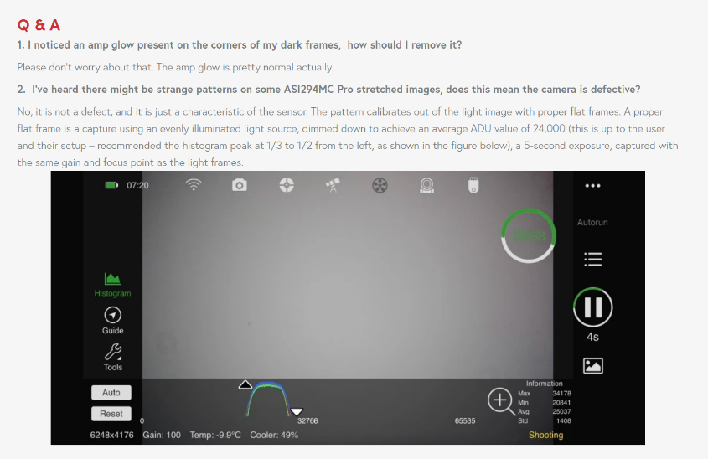
A correct Flat should be acquired with a uniform and attenuated light source, adjusting the intensity of the light and the exposure time in order to bring the average signal of the sensor to approximately 30–50% of the Full Well Capacity, keeping in the linear region and away from saturation. As a practical reference, it is preferable to use exposure times of the order of 2–5 seconds, avoiding excessively short exposures. For Flats, gain is generally of secondary importance, since the signal collected is much greater than the read noise; however, it is advisable to keep the gain consistent with that used for Lights.

Note: The ASI294MC Pro has a nominal Full Well Capacity of 63,700 e⁻. For this camera, ZWO indicates an average value of about 24,000 ADUs as a practical reference for the Flats, with an exposure of about 5 seconds, maintaining the same gain and focus used for the Lights. In our case we use Gain 117, corresponding to the Unity Gain point of the camera
https://www.zwoastro.com/product/asi294/?utm_source=chatgpt.com

The Flats must be performed, as far as possible, with the same Gain used for the Light. The temperature of the sensor is not decisive for the Flat itself, but must be kept the same if Dark Flat is used for its calibration. Cooling must still be carried out in conditions that avoid the formation of condensation.

If you have the possibility, it is good to run the Flats in conditions that avoid light infiltrations.

It is normal for Flats to be vignetted: vignetting and other variations in the lighting of the optical train are among the defects that the Flat is used to correct.
To build a MasterFlat with low noise, 20–40 frames is a common practical range, but the number can be increased if you want to reduce the noise of the MasterFlat even further.

- DARKFLAT
Darkflats are used to calibrate flat frames because they contain both the reading noise and the modest amount of dark current that accumulates on the sensor in that short period of time. These too must always be taken by putting the cap on the lens, with the same time and sensitivity values used for flat frames.
To construct a low-noise MasterDarkFlat, 20–50 frames is a common practice range. The appropriate number depends on the noise of the individual exposure and the accuracy required.
Golden rule: Better fewer well-made frames than many badly made

IMAGE PROCESSING IN PIXINSIGHT
The following is the processing process I follow in PIXINSIGHT.
The processing serves to materially create the image from the union of the many sub-frames made and to normalize it, that is, to correct it from the defects introduced by the limits of electronics and optics.
The phases of which it is composed are not a standard but vary according to the subject and the quality of the frames, therefore each project may eventually require you to skip some phases or to exchange others. Each will then create its own processing flow.
In general, the first phases are calibration with Dark Frame and Flat Field files, then alignment and then stacking, i.e. summing of the images. This is followed by the aesthetic treatment of the images with a different post-production path depending on whether you are working on stars and stellar subjects rather than on nebulae.
This processing process takes place by executing / applying processes and scripts. The use of these requires that before applying it, parameters are set. They are performed by dragging the blue triangle at the bottom left of their windows, on the image to be processed.
The link to the process, with the preset parameters, can however be saved on the workspace with a sequential order of application: to save the link drag their blue triangle not on an image but on the work window you create an icon with an "N" at the top right. By clicking this "N" you can give a name to the link, this must be the most appropriate name to identify its use.
The processes saved in this way, if arranged with a sequential order of application, create a work schedule: having the preset parameters, they can be directly applied by dragging their icon directly onto the image to be processed.
By saving the work project: "Save Project" and giving it a comprehensible name, e.g. Project_Base, these shortcut icons will then be available every time that Project is opened, it will be an aid for subsequent processing.

FRAME SELECTION AND INTEGRATION
In recent versions of PixInsight, the evaluation, selection and weighing of Light frames can be managed directly through Weighted Batch Preprocessing (WBPP). In the current workflow described in this version of the document, WBPP therefore constitutes the main operating method. The Subframe Selector is retained on subsequent pages as a previous procedure and as a didactic reference, but should not be confused with the current WBPP-based method.

- THE SUBFRAME SELECTOR — PREVIOUS PROCEDURE
The "Subframe Selector" process was used in previous versions of PixInsight to analyze, select, and weigh Light frames prior to integration. The procedure is retained in this document for educational and historical purposes and is shown in blue to distinguish it from the current workflow. The formulas in this section, including references to PSFFlux and SNRWeight, belong to the previous procedure and are not the formulas used by the WBPP workflow described below.
Il process si trova in Process > ImageInspection > SubframeSelector
The process opens in three windows: the main SubframeSelector, the Expression window with the selection parameters and the Measurement window with the results.
By saving the icon on the work surface, it retains the set parameters: You can therefore have an icon with the parameters suitable for choosing nebulae frames from perhaps an icon with parameters of more general use.

Prima routine - Measure Subframe: you always start with the Measure Subframe Procedure in the main window.
From the Add Files button, we upload the light files to be analyzed
System Parameters
- Subframe Scale x.xxxx is expressed in arcoseconds/pixel
it is obtained by uploading one of the lights on the Astrometry.net – Upload (https://nova.astrometry.net/upload) website. It is a specific value for each setup consisting of telescope and camera (e.g.: 1.4 arcsec/pixel for my ASI 294 on GSO 154/600 with 32/130 guide; now with 64/120 guide it is worth 1.57)
- Camera gain For ASI 294 with Gain 117 it is worth 1.03746 electrons for data numbers (with Gain 120 it is worth 1.00224).. The value can be obtained by opening an image and from the File menu call FITS Header. On the left of the window that opens find EGAIN, read the value reported. For photo cameras it is practical to use ChatGPT
- Camera resolution 14 bit per ASI 294
- Scale unit Arcseconds (arcsec)
- Data unit Electrons (e-)
Output Files
- Directory the destination folder (e.g. PES – weighted files) to be updated every time
- Prefix is not needed
- PostFix _a
- Keiword SSWEIGHT
- On error Continue

In the second window: Subframe Selector | Expression, the Weighting field indicates the formula for choosing the frames.
Weighting The standard formula is:
(20*(1-(FWHM-FWHMMin)/(FWHMMax-FWHMMin)))+(20*(1-(Eccentricity-EccentricityMin)/(EccentricityMax-EccentricityMin)))+(20*(PSFFlux-PSFFluxMin)/(PSFFluxMax-PSFFluxMin))+50
Where: FWHM expresses the size of the stars must be kept as low as possible
Eccentricity expresses the roundness of the stars : high values indicate that the stars are not round, but elongated
SNR Weight expresses the signal-to-noise ratio , the value must be as high as possible

Then there are standard formulas specific to the subject we want to elaborate:
- To work a nebula:
(10*(1-(FWHM-FWHMMin)/(FWHMMax-FWHMMin)))+(10*(1-(Eccentricity-EccentricityMin)/(EccentricityMax-EccentricityMin)))+(30*(SNRWeight-SNRWeightMin)/(SNRWeightMax-SNRWeightMin))+50

With these formulas we are not imposing numerical limits of deviation but normalizing the parameters within dynamic intervals that derive from our images: from our data. In detail, the "limits" are calculated by:
- FWHMMin → best measured FWHM
- FWHMMax → worst FWHM measured
- EccentricityMin → best value
- EccentricityMax → worst value
- SNRWeightMin → peggior SNR
- SNRWeightMax → Best SNR

So in the standard formula the coefficients (10, 10, 30, +50) are NOT limits, but weights relative to each parameter:
Term Weight
FWHM 10
Eccentricity 10
SNRWeight 30
Offset +50
That is, at Pixinsight we are saying:
"SNR counts 3 times more than FWHM or Eccentricity"
"All frames start at a base weight of 50"
- To work a galaxy:
(15*(1-(FWHM-FWHMMin)/(FWHMMax-FWHMMin)))+(15*(1-(Eccentricity-EccentricityMin)/(EccentricityMax-EccentricityMin)))+(20*(SNRWeight-SNRWeightMin)/(SNRWeightMax-SNRWeightMin))+50

- For a cluster, the best expression would be:
(20*(1-(FWHM-FWHMMin)/(FWHMMax-FWHMMin)))+(20*(1-(Eccentricity-EccentricityMin)/ (EccentricityMax-EccentricityMin)))+(10*(SNRWeight-SNRWeightMin)/(SNRWeightMax-SNRWeightMin))+50

The acceptance of the lights takes place according to the function indicated in the Approval Weight field >70 means that all the lights that exceed 70% of the Weighting formula are accepted.
Once the light files have been loaded and all the fields have been filled in, the measurement process starts using the blue dot.
Once the process is complete, let's examine the third window: Subframe Selector | Measurements, in which we find the analyzed lights, ordered according to the criterion selected in "Measurements Graph". Some, hopefully the majority, are identified with a green stamp as they are judged suitable, while others, indicated by a red cross, are those who, according to the Subframe Selector | Expression, have been discarded from the process.
With reference to each frame, all the values calculated for each parameter are reported.

Second procedure: to end the process, in the main window of Subframe Selector, now you need to switch the "Procedure" from "Measure Subframes" to "Output Subframes".
Do not change parameters, but execute the process using the blue dot in the bar at the bottom left.
Eligible frames will be saved in the chosen destination folder (e.g. PES).

- IL WEIGHTED BATCH PREPROCESSING
Si trova nel menu script > Batch Processing > Weighted Batch Preprocessing Script.
The saved icon retains the previously set parameters, so delete the frames from each label

2a) INTEGRATION OF LIGHTS TAKEN ON DIFFERENT DATES using WBPP (Weighted Batch Pre Processing)
If the different lights are compatible (same Flat) it is sufficient:
- Grouping Keywords Tick the item
- Indicate a reference frame (e.g. DATE, FILTER, etc.) in the free field below
- Insert it in the "Keywords with the green "+" button, all images will be aligned with it.
For example, if you want to integrate lights taken on different dates and with different bias, you need to:
- Create a folder e.g. IC434_Integrated In it you must create as many folders as there are shooting dates.
  - Name these folders "DATE xxyyzz" where xxyyzz are the shooting dates, e.g. "DATE 240114"
- Copy the PES, Flat, Dark and Darkflat folders to each "DATE xxyyzz" folder

2b) THE WBPP PROCESS
This script consists of 7 labels of which the last "Pipeline" simply reports the list of operations performed. In recent versions of PixInsight, WBPP also integrates the Frame Selection phase, allowing you to evaluate and manage Light frames directly within the workflow. It is therefore not necessary to manually build the weighting formulas used in the previous procedure with Subframe Selector. The parameters and formulas of the old Subframe Selector, shown in blue in the previous section, are kept exclusively for reference.

Prima LABEL - Caricare i frames BIAS
The parameters are:
Combination Average
Rejection algorithm Auto, oppure:
- Averaged Sigma Clipping if we have less than 10 frames
- Winsorized Sigma Clipping if we have 10 to 20 frames
- Linear Fit Clipping if we have more than 20 frames

Second LABEL - Load DARKS frames, even of different durations and also DARK FLATS
The parameters are:
Combination Average
Rejection algorithm Auto (or we set it as mentioned for the first label)
You can possibly adjust the shutter speed tolerance:
Exposure tolerance The exposure tolerance determines how much the exposure times of frames can differ for WBPP to consider them to be in the same calibration group. A low value should be kept so that Dark captured at different times remains properly distinct. It should not be increased to use the same Dark with Light captured at different exposure times.

Third LABEL - Loading FLATS frames
The parameters are:
Combination Average
Rejection algorithm Auto (or we set it as mentioned for the first label

Fourth LABEL - Load the LIGHT frames by taking them from the destination folder chosen before (e.g. PES).
The script allows you to work with groups of files with homogeneous characteristics and, if necessary, also to work with groups of files that are different from each other both in terms of exposure duration and, in the case of using filters or different dates, through the use of keywords. In any case, it is also always possible to obtain a single integration, a single master light by acting on the Calibration Exposure Tolerance
- Calibration Exposure Tolerance A low value allows WBPP to keep calibration groups performed at different times separate.
WBPP must be able to calibrate each group of Lights with the appropriate calibration frames, i.e. keeping the groups with different exposures separate. It is therefore not correct to use Calibration Exposure Tolerance to make WBPP consider the same Dark compatible with Lights acquired with different exposure times.
If, after calibration, you want to obtain a single integration of Lights acquired with different exposure times, this operation must be managed in the Post-Calibration phase, using the options provided by WBPP.
To allow Light groups with different exposure times to be merged, the value used in Post-Calibration must be greater than the difference between the longest and shortest exposure time.
For example, for Light captured at 120 s and 180 s, the difference is 60 s; therefore, the value must be greater than 60 s.
- Linear Defect Correction leave it unchecked.
- Subframe Weighting must be flagged and the Weighting Formula is chosen from the drop-down menu.
  - In the "Weighting Formula Parameters" window you can set the parameters provided by the selected formula.
- Frame Selection This item allows you to perform frame selection directly within WBPP, avoiding having to perform the old Subframe Selector procedure beforehand.
  - If "Interactive" is flagged, the WBPP process stops at the selection stage to allow the Rejection Filters to be set; the process then continues using the frames that fall within the chosen criteria.
- Image Registration va flaggata
  - Registration parameters leave automatically, flag only the Distortion Correction item
- Local Normalization can be very useful when subframes have differences in background, transparency, or intensity, especially in datasets captured over multiple nights. However, it is not mandatory in every process.
To assess its usefulness, you can compare the integration of the same dataset with Local Normalization on and off, while keeping the other settings the same. If normalization improves the uniformity of the background without introducing artifacts, it can be kept in the workflow.
- Image Integration va flaggata
  - Autocrop should be flagged to make the crop do automatically, but only if you work with a single final image. In the case that you have to combine images made with 2 different filters, it is better not to use it but to combine them later
  - Integration parameters: Combination Average e Rejection algorithm Auto
- Astrometric Solution lasciare flaggata, flaggare la Interactive in case of failure
- Grouping Keyword (right side of the process window) should be flagged when working with groups of images with different characteristics
  - In the case of groups with different shooting dates, to integrate with each other, indicate the word "DATE" in the Keyword field (which distinguishes the directories of the same subject, but produced at different times) and make it operational by means of a green "+" icon

Note: Capturing deep-sky objects requires many hours of imaging, often for many nights. This leads to variations in atmospheric conditions and light pollution gradients in different parts of the sky. Subframes shot at different times can therefore have different background levels and gradients. PixInsight's Local Normalization process can compensate for these variations when normalizing subframes.

Fifth LABEL - CALIBRATION - you will find a schematic summary of what the script will do.
Clicking on each item activates the files involved in the calibration of the item itself in green.
In the Calibration label, by clicking on the Lights item, on the right you activate the items:
Calibration Setting:
- Dark Auto
- Flat Auto;
- Optimize Master Dark only flag if you don't have the correct dark as exposure
Cosmetic Correction:
- Automatic Leave tick
CFA settings, it concerns the debayer of our image:
- CFA images should only be flagged if the image is in color
- Mosaic pattern Normally in Auto it should recognize the Bayer matrix of the camera
- Debayer method VNG
The Show Calibration Diagram button graphically shows how the calibration steps take place.

By clicking on the Flats item of the Calibration label, on the right you activate the items:
In CFA Setting:
- CFA images must be flagged if the image is in color
- The Show Calibration Diagram button graphically shows how the calibration steps take place.

On the right of the WBPP window:
- Registration Reference Image:
Mode Choose Auto if we have a single set of images made with a single filter (or without) and a single subject The script automatically identifies the frame to be used as a reference when aligning the lights, if left in Auto the script analyzes the images for us choosing the one that will have the best FWHM i.e. the lowest value and the highest SNR
Mode Use Manual if we have 2 or more sets of images made with different filters, different times, etc. that need to be integrated into a single final image. In this case you need to choose a reference image, among the most beautiful ones of the sets.

Sixth LABEL - POST-CALIBRATION – Shows the result of what we will get after the process has been completed, the number of lights, the exposure time, the total integration time due to the sum of all the light subframes.
On the right, voices are activated
- Exposure tolerance indicate a value appropriate to the result to be obtained
  - with a low value (e.g. "2"), if we have a homogeneous group of frames or if we have worked frames with exposures of different duration or with different filters, we will have groups of files for each time or in the case of filters, separate for each filter
  - a high value (e.g. "200"), allows you to unify under a single group even groups of lights that differ from each other in terms of exposure time or filter used.
- Channels configuration we can choose whether to obtain a combined RGB master light, or the individual channels, or both
  - Below that you will see the steps that are active in the process, i.e. calibration, alignment, and summing
- Drizzle configuration Drizzle can be useful for retrieving some of the resolution when the dataset is downsampled, thanks to the combination of multiple ditherated images. However, it does not create information that is not present in the original data and is not automatically needed for every dataset.
  - Fast mode: if activated it is faster, but also less precise
  - Scale: 1 produces an output at the original scale (has almost no effect); 2 increases the scale of the image and can be useful with sufficiently undersampled data and with an adequate number of frames and dithering; 3 requires particularly favorable conditions and amounts of data (exposures made with good and stable seeing). There is therefore no universally "standard" Scale 2.
  - Drop shrink: Control how much to "tighten" the pixel drizzle:
- 1.0 → softer
- 0.9 → Balanced (Real Default)
- 0.8 → more detail but more noise (to be used only if you have many frames)
  - Function: Defines how drizzle pixels are combined:
- Square (default) is one of the available distribution features and is a general choice;
- Gaussian produces a softer distribution (less noise, slight smoothing). The choice depends on the dataset and the desired trade-off between detail, noise and resolution (preferable to use it only if you have high noise).
  - Grid: leave as per default, check the internal grid of the drizzle (optimization that does NOT change the result in a visible way)
- Grouping Keywords Allows, by means of keywords inserted upstream in the file naming, to easily work with filters for groups of files identified by these keywords.
- Global Option: The Global Options panel contains settings that affect the overall behavior of the script, rather than the quality of the actual processing. Many can safely remain at their default values.
- FITS Orientation: Determines how to interpret the orientation of FITS images (Top-Down, Bottom-Up, or Global Preferences). Global Pref in almost all cases.
- Compat GUI: (means Compatibility Graphical User Interface): In WBPP it is an option designed for compatibility with older versions of the script interface. It does not change the calibration, registration or integration algorithms in any way, but only changes the appearance and behavior of the interface. You don't need to activate it.
- Detect Masters from Path: If it finds Master Bias, Dark or Flat in the workbook it automatically recognizes them without having to manually select them. Then ON
- Generate Rejection Maps: Saves maps of pixels discarded during integration (useful for checking satellites, hot pixels, etc.). ON if there are no disk space issues.
- Preserve White Balance: Maintains the white balance coefficients recorded by the OSC camera. Generally OFF for astrophotography, except for special needs.
- Save Groups on Exit: Stores the loaded image groups when WBPP is closed. Then ON
- Smart Naming Override: Allows you to customize the name of the files produced instead of the automatic nomenclature of WBPP. Normally OFF.
- Purge Cache: Clears the WBPP's internal cache. It is only needed when the behavior seems abnormal or you want to force a complete recalculation. Use only when necessary.
- Output Directory Indicate a destination folder for our processed files (e.g. PIX) where, at the end of the process, you can find the various masters, the debayerized files, the aligned files and possibly the drizzle files.
The large and central summary window shows the groups of frames that will be integrated according to the choices made and the time of total integration for each group.
At this point press the Diagnostic button It shows if everything we have loaded and the settings put are correct or if there are no problems. If the diagnosis gives the ok then we run the RUN.
Run The process starts and we can see the workflow scroll quickly on the Process Console on the left.

When the process reaches the Frame Selection stage, a screen divided into 4 windows will open.
The Frames Group window shows our lights divided into groups according to the Grouping keywords defined in the fourth label.
The Frames in Selected Groups window shows the list of our frames with the relative parameters calculated for each.
The Frame Metrics window graphically shows the sequence of our frames for each of the parameters: FWHM, Eccentricity, PSF Signal Weight, Median, Stars, Custom Formula.
The window on the right shows the Rejection Filters, with which we can select, for each group, the parameter or parameters to be used to exclude the frames less suitable for integration. The choice of criteria must be made according to the subject and the characteristics of the dataset, without applying universal numerical thresholds.
However, the parameters to be considered are:
- FWHM means width at half the height of the peak. It basically measures how "wide" a star is in the image. Imagining the light profile of a star, it is very bright in the center while it drops towards the edges. FWHM is expressed in pixels and measures the width of the star at the point where the brightness is at 50% of the maximum. It is affected by focus, seeing, optics, tracking and overall shooting conditions. There is no absolute "right" value: the limit depends on the image scale, instrument and shooting conditions. All things being equal, lower values generally correspond to narrower stars.
- Eccentricity measures how far the star shape deviates from circularity. Lower values are generally favorable, but there is no universal threshold. A threshold of about 0.5 can be used as a practical selection criterion in certain datasets, but it must be checked against your own images and needs.
- The PSF Signal Weight parameter is a weighting criterion based on the stellar signal used in the characterization of the PSF (Point Spread Function). The PSF describes how the light from a point star is distributed on the sensor, as a function of the combined effect of the optics, the atmosphere, the focus, the tracking and the other characteristics of the imaging system.
The PSF Signal Weight is therefore not a direct indicator of the sharpness or shape of the star. The width of the star profile is evaluated primarily by FWHM, while any elongation is evaluated by eccentricity. The PSF Signal Weight, on the other hand, provides complementary information that is used to assign a weight to frames according to this criterion.
A higher value is generally favorable, but it does not necessarily mean that the frame has sharper stars. The parameter must therefore be evaluated together with FWHM, eccentricity, number of stars, background sky and, above all, according to the lens of the shot.

Note: PSF is the distribution of the star's light signal around its central point, while the FWHM measures a characteristic of the PSF, i.e. its width at half height.
The PSF Signal Weight therefore provides complementary information to the FWHM and eccentricity and must be interpreted in the context of the weighting criterion selected in WBPP.

- The median is an indicator of the brightness level of the background sky and can be useful for detecting changes in transparency, haze, moon or gradients. It does not directly measure seeing or focus. The numerical values of the median are highly dependent on camera, gain, offset, exposure, filter and calibration.
Previously it was said that in deep-sky shots: 0.003 – 0.010 → indicated dark sky; 0.010 – 0.020 → clear sky / Moon / haze; Beyond 0.02 → heavily compromised frames, but for what has been said they are not to be considered as absolute reference values, but are more useful as a relative reference within the same dataset.
- The number of stars is the count of the stars detected. With the same field and conditions, a higher number may be indicative of better transparency or a more favorable background, but it does not automatically mean that the frame is better: seeing, focus, eccentricity and noise must also be considered.
- The metrics available at this stage should be interpreted according to the criterion selected in the WBPP. SNRWeight, used in the old Subframe Selector formulas shown in blue, is no longer present in the current WBPP.

2c) CRITERIA FOR SELECTING LIGHT
In the selection of the Light, the FWHM is one of the most important indicators to evaluate the sharpness of the stars and therefore the resolution obtainable in the final image. The eccentricity, on the other hand, allows the detection of any elongation of the stars, due for example to tracking or driving problems. The PSF Signal Weight provides complementary information based on the characterization of the PSF and is used as a weighting criterion; it should not be interpreted as a direct measurement of the sharpness of the stars.
The choice of parameters to be favored also depends on the type of subject photographed.
For images in which stars are an important element of the subject, such as galaxies and star clusters, it is particularly important to preserve the quality and definition of the stars. In this case, FWHM and eccentricity take on a particularly important weight: FWHM allows the width of the stellar profile to be evaluated, while eccentricity allows any elongation to be detected.
For nebula images, especially diffuse images with faint structures, the selection of Light requires a more comprehensive evaluation of the frame. FWHM remains important for the quality of the stellar component and for the definition of fine structures, but it should not be used in isolation. The quality of the nebula signal, the signal-to-noise ratio, the background sky and the transparency should also be considered, because a frame with slightly less narrow stars can still contain useful information about the faint nebulosity.
In this context, the PSF Signal Weight can provide a complementary weighting criterion and can therefore be useful in the evaluation of the frames intended for the processing of nebulae. However, it should not be interpreted either as a direct index of the sharpness of the stars or as a measure of the quality of the nebula.
In summary:
Galaxies and clusters → FWHM + eccentricity assume a particularly important weight in the evaluation of the stellar component.
Nebulae → FWHM + signal quality, signal-to-noise ratio, background sky and transparency should be evaluated as a whole; the PSF Signal Weight can provide a complementary weighting criterion.
After clicking on a frame whose level seems to us to be a limit of acceptability for a certain parameter, clicking on the icon with the graph in correspondence with the discriminating parameter, the reference limit for that parameter will be created: you just have to choose whether the frames must have a value greater or lower than this value.
Double-clicking on individual frames opens them in a preview window to understand their qualitative appearance.
Frames can be discarded/accepted individually: after highlighting them, click the "Disable Frame"/"Enable Frame" icon.
We then choose the parameters according to the criteria explained here, the Frames Group window will indicate the number of files used, the number of files discarded and the number of those we have disabled.
We give the OK to continue the process.
During this:
- the individual Dark frames are mediated and integrated to create a Dark Master
- the Dark Master is subtracted from each individual Light frame
- the Flat Darks are mediated and integrated to create a Master Flat Dark that is subtracted from each Flat frame
- the Flats calibrated in this way are mediated to form a Master Flat
- Every single Light already corrected with the Master Dark is divided by the Master Flat.
At the end we will have the calibrated Light frames ready to be debayerized and aligned for stacking.
If the WBPP does not work: Process ImageIntegration then Script ImageAnalisys Image Solver, then restart the WBPP. At the end of the process a report will open indicating everything that happened, if everything went well or if there were problems or errors.
Once the WBPP is closed, we can open the Master Light file from the MASTER folder to save it, and start processing it.

AESTHETIC IMAGE TREATMENT
Everything you do: scripts or processes, remains visible in the Process Console that opens on the left side of the work window.

- LINEAR PHASE PROCESSING
From the MASTER folder, open the master light image RGB_autocrop. The image to be processed is now black, only the stars can be seen as it is still in the linear phase.
Close rejection images that open at the same time
Open the STF (Screen Transfer Function) Autostretch process that simulates what the stretched image will look like.
The process can be found in the Process menu > Intensity Transformations > Screen Transfer Function
The saved icon retains the previously set parameters
- Clicking on the chain symbol when it is no longer highlighted, indicates that the merged adjustment of the RGB channels (otherwise incorrect colors) is unfastened.
- Click on Autostretch (radioactive symbol) the colors are now better, more real
- If we reset, the image goes back to how it was before
In this case, we can improve the view of the details of the image by operating manually:
- click on the "+" icon that zooms in on the color bands
- move the mouse pointer to the far left of each band and click until the mid and dark tone indicators are enlarged
- click on the arrow icon again to return to Edit mode
- move the individual indicators to give more light to the details and facilitate future adjustments
- with the icon of the radioactive symbol you can return to the initial conditions

- IMPOSTARE L'RGB WORKING SPACE A 1:1:1
Open the RGB Working Space process. This process defines the weights and coefficients used by PixInsight for operations involving the three RGB channels and the luminance derived from the image.
The process can be found in the Process menu > Color Spaces > RGB Working Space.
Setting the luminance values of the three channels R, G, and B to 1 allows you to use a 1:1:1 setting, in which the three channels are treated with equal weight. This does not mean that the brightness or signal of the three channels is equal, nor does it directly change the pixels in the image.
The 1:1:1 setting can be useful in some processing where PixInsight uses an implicit luminance derived from RGB channels, and in particular image processing operations.
Apply the process by dragging the blue triangle across the image field.

Before the RGB Working Space 1:1:1 setting was available, the Split RGB Channels, LinearFit, and subsequent Channel Combination method could be used to normalize the levels of the three RGB channels.
The Split RGB Channels (icon next to the Luminance icon) would split the image into the 3 channels Red, Blue and Green.
Then you would have to open the LinearFit process in which you would indicate the green channel as the reference image and then pull the blue triangle of the process on the images of the Red and Blue channels.
Finally, through the process Channel Combination, working in ColorSpace RGB we recombine the three individual channels that we would respectively recall through the side icons. Round Apply button. Close the processes and the 3 equalized channels and give a name to the image obtained.
LinearFit has not simply been "replaced" by SPCC. SPCC calibrates the color of the image photometrically, while LinearFit is a relative normalization tool between images. In some workflows, it can therefore remain useful, even when using SPCC.

Color Balance
Before color calibration, it is often useful to correct gradients and make sure that the background is representative. Background Neutralization can be used when it is used to neutralize the background, but it is not a mandatory step before each gradient correction or before SPCC. If SPCC is used, photometric calibration and background management must be set up in a way that is consistent with the chosen workflow.

PREPARING IMAGES TO BE MERGED IN THE NEXT STEPS

- IMAGE ROTATION
If we have several images to merge because they were taken with different exposure times, for example, we must first have them all rotated in the same direction. This is achieved through the Fast Rotation process.
Si trova in Process > Geometry > Fast Rotation
- Open the process
- Indicate the desired rotation
Apply via the blue square button on the bottom left.
Note: If the light frames have been recorded correctly (i.e. using the same reference frame for all lights) this operation as well as the next step should not be necessary as the frames should already be in the correct position.

- ALIGN IMAGES
The next step is to align them with each other, with respect to one of them, through the Star Alignment process
Si trova in Process > Image Registration > Star Alignment
Reference Image gives a reference image chosen from View/File from the adjacent drop-down
Target image add files to align (both RGB and narrowband)
Apply the process click blue dot at the bottom left

- DYNAMIC CROP
If following Star Alignment you have images with different orientations, before performing the next step of eliminating gradients, it is advisable to cut out the empty parts, without signal. If left, these areas would give rise to color aberrations in the subsequent phases.
Open the Dynamic Crop process Used to define the useful area of the image
The process can be found in the Process menu > Geometry > Dynamic Crop

- The mouse takes a square shape with a crossroads in the middle and a contour line is formed to the image Go with the mouse in the middle of the sides of the contour to the square shape of the pointer a vertex is formed
- Holding down the left mouse button, move the margin lines to the desired position to eliminate the empty areas, i.e. discarding the edges that have defects
- Drag the blue process triangle over all the images you want to crop equally
- Apply the crop using the green flag : the edge of all images is cropped equally.

Note: By intervening on Rotation and the other fields of the process, it is possible to make custom crops
Note: From this point here you will no longer have to vary anything dimensionally on the images (e.g. the crop) otherwise you will no longer be able to align them and put them back together

After cropping the images automatically, they lose their astrometric references, so it is necessary to restore them using the image solver script.

- IMAGE SOLVER OF THE IMAGE
Open the Image Solver script
Si trova in Script > Astrometry > Image Solver
- Image Parameters indicate date on which the shot was taken
  - in the case of an image derived from grouping images with different shooting dates, indicate at least one of their dates
- Fare Search indicare l’Object identifier Search dare OK
- Model Parameters indicate Local XPSD Gaia DR3 (XPSD) if present on our computer otherwise leave it in AUTO.
Execute the script using the "OK" button

Note: during the process it may happen that you are unable to complete some process, it is a good idea to repeat the Image Solver script and try again. Very often this is effective.

- FIRST NOISE REDUCTION
Right-click on the photo, choose Identifier Rename the file to "B"
Right-click on the photo, choose Duplicate Duplicate Duplicate the image > it will automatically be named "Clone"
  - You can also do this by snapping the photo label and dragging it to the side
Right-click on the "Clone" photo, choose Identifier Rename the file to "R" which stands for noise
Now let's work on image R, let's temporarily leave aside our main image B

9a) Apriamo il process ATrous Wavelet Transform
The process can be found in the Process > Compatibility menu > ATrous Wavelet Transform
The process, acting only on levels 1–2, serves to reduce noise (high frequency) without losing real structure
The same process acting on the medium levels emphasizes nebulosity and pulls out filaments, improves local contrast
The noise lives mainly in the first two levels while the real signal is in the medium and large levels. This process allows them to be treated selectively and non-destructively.
- In this beginning of processing we leave active (with the green checkmark) only the first Layer while with double click on the green check we deactivate the others that now take the red X
- Let's leave the other parameters as default, without activating Noise Reduction
- We apply the process with the usual triangle that we bring to photo R we will see that it becomes black
- If we apply the STF, we will notice that we only see the grain of noise, which is what we want to eliminate.
The icon saved on the work surface keeps the parameters as set.
Alternatively, you can use MultiscaleLinearTransform: a modern, more flexible evolution, with integrated masks

9b) NOISE SUBTRACTION
Let's open the PixelMath process
The process is located in the Process menu > PixelMath > PixelMath
- Expressions we write the expression "name of our main photo – noise": e.g. B-R,
- Destination lasciamo Replace Target Image
- We apply the process to the main image B by bringing the blue triangle over it
Let's close image R, we won't need it anymore

- GRADIENT ELIMINATION
It is used to uniform the deep sky by eliminating all the brightness unevenness due to vignetting due to incorrect execution of the flats or from light pollution that makes one area of the sky brighter than the other (gradients). The elimination of gradients can be performed in various ways, in the past the ABE Gradients, Dynamic Background Extraction, then Graxpert processes were used. Recently we have seen the use of Gradient Correction and now the use of Multiscale Gradient Correction is being implemented which exploits the MARS project, a new project for the correction of additive gradients in astronomical images of the deep sky based on observational data, which, as reported in the official Pixinsight documentation https://pixinsight.com/doc/docs/MARS/MARS.html will be the basis of the next generation of gradient correction algorithms and tools in PixInsight.
Before being able to perform the Multiscale Gradient Correction, it is necessary to do the Spectrophotometric Flux Calibration and possibly, in case of errors, it is necessary to do the Image Solver.
Both SPFC and MGC should always be applied in the linear phase (before stretching).

- SPETTROPHOTOMETRIC FLUX CALIBRATION
Spettrophotometric Flux Calibration si trova in Process > Spectrophotometry > Spettrophotometric Flux Calibration
Settings:
QE curve: Ideal QE curve if sensor-specific curve is not available
Grey filter: you put the luminance filter if you have a B/W camera, otherwise you put Ideal QE curve
Red, Green, Blue filter: indicate the custom filter camera+filter
Press OK by means of a blue square button the program reads the 20 files of GAIA DR3/SP and creates a graph of the 3 colors R/G/B
Once the process and the graph are closed, move on to do the Multiscale Gradient Correction

- MULTISCALE GRADIENT CORRECTION
The process can be found in the Process menu > Multiscale Processing > Multiscale Gradient Correction
- Mars Database: Add the MARS-DR1-1.1.1.xmars and MARS-DR1-u01-1.0.1.xmars files. If already connected via wrench, just choose Default Files
- By default, the parameters are:
  - Gradient scale: 1024
  - Structure separation: 3
  - Scale factor: everything at 1,000
Execute the process using a blue square button An image of the subtracted background is created, visible through STF.
It is often convenient to go back and try to manage the parameters manually until you find more readability in the details.

- GRADIENT CORRECTION
Alternatively, open the Gradient Correction process
The process is located in the Process menu > GradientCorrection > GradientCorrection
Normally you don't need to change Blue Triangle parameters on the image to be processed
If in the case of particularly difficult gradients we have to interact with the different process adjustments, there may be the problem of not correcting enough or overcorrecting, losing weak nuances or/and damaging the highlights. The threshold and tolerance values tell him what to consider a gradient: with their adjustment, a greater or lesser number of nuances will be taken into account, both for highs and lowlights.
By exploiting Structure Protection, a mask is created to protect the highlights.
If the gradient is particularly complex, it is worth reducing the scale of the model, making it work on finer details and in this case it is recommended to reduce the smoothness as well.
A function that is always worth using is Automatic convergence for which the process will repeat itself iteratively until it calculates that the last correction made is substantially the same as the previous one.
Using Simplified Model, polynomial functions capable of using only linear gradients (first degree) will be used, while from the second degree a vignette should also be correctable with increasing efficiency as the degree of the function increases, until it overcorrects, so it is necessary to perform various tests until the optimal result is obtained.
The process builds a pseudo-flat that reproduces the gradient that it then subtracts from the image.

- ABE GRADIENTS
It is almost no longer performed, but remains as an alternative
Open the ABE Gradients process. (Automatic Background Extractor), is an automatic process
The process can be found in the Process > Background Modellization > Automatic Background Extractor menu
The saved icon retains the previously set parameters.
In the Sample Generation section, increasing the Box separation value will create fewer reference points on which to calculate the brightness variation, fewer samples can often produce better results. From the default value of 5, going up to 10 or 15 can be a good start
In the Interpolation and Output section, the parameters to be set are:
- Function Degree we set it to the minimum i.e. 1 serves high only in the case of very complex gradients
- The Downsampling factor can also be increased to 1.00
In the Target Image Correction section:
- Correction we choose Subtraction when we have pollution gradients
  - we choose Division only if we have only some imbalance, or perhaps the absence of Flats or some darker part but not real pollution gradients
- We flag the Normalize entry.
- In the Identifier field we indicate ABE_Nome file the program does not allow blank spaces in the name to put the symbol "_" between one word and another.
We apply the process with the usual triangle dragged over the image. The process will create 2 images: the first is our processed image, the second is the calculated light gradient model.
We apply the Screen Transfer Function to both to see the result.
If we see that the calculated light gradient model is posterized, we activate the 24-bit display by means of a special icon at the top, next to the monitor, with the word 24 to see it faded as it should actually be.

- BACKGROUND ADJUSTMENT
Useful for extracting greater contrast between the subject and the background sky
We open the Dynamic Background Extraction process to extract and adjust the background semi-automatically.
Si trova in Process > Background Modelization > Dynamic Background Extraction
A cross appears on the image that divides the photo into four quadrants.
Start from the Sample Generation section. By clicking on the Generate button, the first reference points are automatically laid, in all or part of the image. With the default parameters set, it is possible that very few points are produced. You must then intervene on the parameters:
- In the Model Parameters section (1), the default Tolerance is 0.5 The Tolerance value manages the tolerance, increasing it allows you to intervene on larger areas of the image, and vice versa
- Go back to the Sample Generation section and click on Generate again to see the result. To have a greater coverage of crosses just increase the Samples per Row If the points do not cover the entire image or if they also cover part of the nebula, you need to change the Tolerance value again and then click on Generate again.

Note: The monitor of the process window shows the magnification of the individual samples that we place. If they are not clearly visible, we increase the Default Sample Radius from 5 to about 15 – 20.

- The Minimum Sample Weight in the Sample Generation section also regulates the tolerance in another way and can also be lowered significantly
- Increasing the value of Shadows relaxation in the Model Parameters section (1) increases the tolerance for dark pixels: another way to tell the process what is background and what is not.

After doing some tests and finding the right Tolerance value Reset the process, reset the suitable values found, do the Generate and go, with the simple click of the mouse on the image, to manually add additional points of deep sky in the areas that most need correction, e.g. the dark corners of a vignette.
- With the mouse cross, click on the deep sky areas, where there is no dust or even nebulosity. Markers (Sample points) are inserted. You need at least 5 in each quadrant, distributed both in the peripheral areas, but also for the whole image in order to create a complete and representative model of our photography.
  - Larger quantities allow a more detailed background model, they will be references for the regularization of the background sky and the elimination of color casts.

Note: It should be remembered that placing too many samples in the end ends up being counterproductive: the model of the The gradient should be as smooth and nuanced as possible: 10 Samples per row automatically generated there can be too many and we can reduce them to 7 or 5 by manually adding the ones we need.

- When we place a marker, in the preview area of the process window you will see the pixels of the marked point if they are all clear, their position is suitable, otherwise the presence of pixels of various colors or black colors indicates that we have placed the marker on an unsuitable area
- Even the markers themselves, when aiming, take on a color indicating their suitability: green if placed in a suitable position of deep sky, red if not suitable
- We move or remove any sample points that have a red marker or / and many black pixels: the light pixels are the darkest areas of the sky in which we must have selected these markers
  - If you are unable to have green markers (but remain red), progressively increase the Tolerance (up to a maximum of 1) until the green samples are returned. Markers that are red indicate that they are not managed in this Tolerance value
- In the Target Image Correction section , select the correction you want to apply to the photo:
  - If we do not select anything we will only get the background model without any action on the photo it may be convenient to do the DBE several times without selecting the Target Image Correction in order to see through the background image, the best result, achievable by increasing / moving the markers
  - If we need to correct noise gradients due to light pollution or the presence of moonlight, we must use Subtraction; if we want to correct any vignetting, we must choose Division.
  - If you want, you can do the two steps, the subtraction first and the division later.
- Normalize is not needed because normalization is done by SPCC.
- Discard Background Model do not check: at the end of execution it shows the map of the sky model.
Let's apply the process by bringing the blue triangle to the image.
- Background image is created and looked at through the STF and checked to make sure that only background noise has been discarded
Our image is now cleaner If not applied by the process, we add DBE to the name

- After applying the process for the first time, the most effective way to use this process is to drag the blue triangle to the desktop as well. In this way the process icon is saved on the desktop with the aforementioned parameters set by clicking on the created icon, the process reopens showing on the image all the markers used, but now, having the image improved from the first execution of the process, we can now move those markers that we see in the inappropriate area, in areas that were not visible before.
- I move the misplaced markers, I can also add more I apply the process again, but now I get an even better result
- This repetition can be applied several times until the best result is obtained

Note: In the case of images with high light pollution or lack of data, this process may be ineffective.
Note: This process can be applied as many times as you want to further enhance the image, perhaps increase the Tolerance a little more if there are areas that are not yet well balanced.

- BACKGROUND ADJUSTMENT by automated method
The Dynamic Background Extraction process to extract and regularize the background of our image can be applied automatically through SetiAstro's Automatic DBE tool.
Found in Scripts > SetiAstro > Automatic DBE
Once you have selected the image to be processed in the Select Image drop-down menu, just click Execute to run the script.
Many window windows will open and then when they close again they will leave the improved image

- GRADIENT ELIMINATION with GRAXPERT
Yet another alternative
Let's open the GraXpert process
The process is located in Process > "Etc" > GraXpert (As scripts they have the same features and functions)
The process groups both Background Extraction and Denoising, but they can be activated one at a time.
Background Extraction
- Smoothing Factor Adjust the control value of GraXpert if necessary. In most cases, the default smoothing factor of 0.0 should be the best choice.
- Correction we choose Subtraction when we have pollution gradients
we choose Division only if we have only some imbalance, or perhaps the absence of Flats or some darker part but not real pollution gradients
- Confirm the application of the process using the blue triangle at the bottom left
Denoising
- We activate the preview via the blue circle at the bottom left
- Strength select the intensity of noise reduction to be performed keeping in mind that excessive noise reduction may seem unnatural! Valid values from 0 to 1, default is 0.5
- Batch size The number of parts of the image in which Graxpert will treat noise in parallel. Batch size is an optional parameter used only to improve performance, and the best value depends entirely on the hardware. Default 4
- Confirm the application of the process using the blue square at the bottom left The result is more drastic than the preview

- COLOR CALIBRATION
Color Calibration (only works with linear images) is used to adjust it and make it as natural and realistic as possible.
Apriamo il process Spectro Photometric Color Calibration.
Si trova in Process > Color Calibration > Spectro Photometric Color Calibration.
The parameters to be set are:
- White reference : working with color cameras sets Average Spiral Galaxy because galaxies contain all the emission bands and therefore are perfect as a white reference.
- In the case of a monochrome sensor, select the camera sensor specifically from the drop-down menu. If it is not present, select "ideal QE" from the list.
- QE curves Choose the sensor in the list. If ours is not listed in the list of common sensors, choose Ideal QE Curve. Their QE will be managed in the R/G/B filter fields via custom curves.
- Red filter Sony Color Sensor R (if you don't have filters, otherwise choose the correct sensor + filter)
- Green filter Sony Color Sensor G (ditto as above)
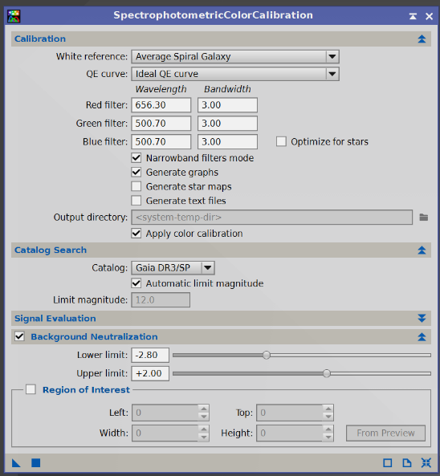
- Blue filter Sony Color Sensor B (ditto as above)

Note: When working with narrowband filters, choose the combination sensor + filter from the list. If it is not present, you can create a custom filter, or for monochrome sensors on Narrowband filters mode and specify the relative values of Wavelength and Bandwidth, i.e. wavelengths and bandwidths.

- Generate Graph if flagged will show the maching references of the stars found during the calibration phase
- Apply Color Calibration must be flagged for the calibration to be applied to our image.
- Catalog the Gaia DR3/SP should be selected which is specific for spectrophotometry
- Automatic Limit Magnitude must be flagged so that the process can identify visible stars
- Signal Evaluation leave default values
- Background Neutralization must be flagged and applied to the region of interest
- Region of interest va flaggata,
  - Now create a small Preview (rectangle icon with shadow in the Pixinsight menu) in an area of the background of our photo, a point not affected by the nebula: the SetiAstro Find Background script can be a valuable help in cases of too many stars to manually define an area, even a small one. Once the script is open, just click Search.
  - click on the "From Preview" item in the process to have the background-sky evaluated
- From Preview drop-down menu, choose the preview created and press OK
Let's apply the process by bringing the blue triangle to the image.
- In the returned graph the stars must be aligned as much as possible on a straight line, otherwise it means that something went wrong, it did not work In case, do Undo on the image and repeat the process, otherwise close the graph window
The resulting image is black, so I click on STF AutoStretch after relocking the channels by clicking on the chain icon the penultimate icon on the top window of Pixinsight, which re-enables the STF to review the stretched colors.

- SYNTHETIC FLAT
If there are disturbances due to Flat that for various reasons have not been well managed, and if the subject is well defined and simple, e.g. galaxies or clusters, you can try to solve the problem through a Synthetic Flat.
This is a synthetic Flat generated from the image that has the defect and used using PixelMath to manually model and correct the uneven response. It is a recovery technique that should be used with caution and is not a substitute for a Flat that was captured correctly during shooting.
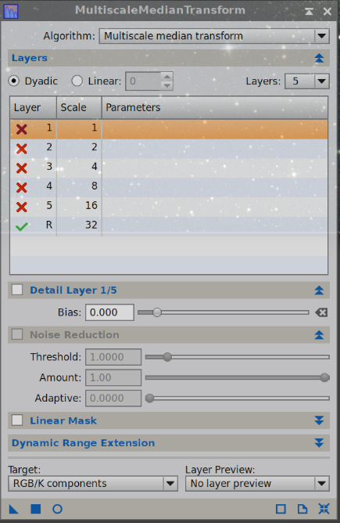
Procedure:
- Duplicate the image and rename it FLAT
- Eliminating stars (which we do not keep) through Starnet2_Linear we are in a linear phase
- We highlight flaws with MultiscaleMediaTransform
Si trova in Process- MultiscaleProcessing > MultiscaleMediaTransform
We add a Layer reaching 5 but we turn them all off (double click on each) leaving only the last "R" on and we apply the image by means of a blue tab it loses definition and goes to blur leaving the defects evident
- We eliminate galaxies and clusters using CloneStamp that we use with Softness 0.50 and opacity 0.70; technically we obtain a surface that can be used to build the synthetic Flat. The values indicated are practical examples and must be adapted to the result.
- Using PixelMath we now apply this flat to the image, writing the formula:
$T * mean(FLAT)/FLAT
where we have $T is the total of the signal that we multiply by the average of the FLAT divided by the FLAT itself , we drag the blue triangle on the image to be corrected and here is the calibrated image.
From https://www.youtube.com/watch?v=ABFydJXkaW4

- BRINGING COLOR CHANNELS TOGETHER
Once the process is finished, the channels are still separated, so it is necessary to reunite/rechain the color channels:
- open the Process STF on the photo click the chain symbol
- Apply the process by clicking on the "radioactive" symbol the colors are brought to how they actually are.
If desired, it is possible to apply the SCNR process to eliminate any green dominants still present

- HDR COMPOSITION OPTION to merge different images e.g. with different exposure times
Then we can continue with the HDR Composition process.
This process will generate a 64-bit image, no longer 32, containing a much wider dynamic range of the image, without burning either the high-light areas or the shadows.
Let's first prepare the files to be merged , save them in XISF format – 32 bit
Let's open the HDR Composition process
Si trova in Process > Image Integration > HDR Composition
- We add the images using the Add Files button , the search directory opens from which we can also choose several files together
- We must order them in descending order of exposure time, that is, keep the images with the longest exposures at the top of the list Edit the list using the Move Up and Move Down buttons
- Automatic exposure evaluation check so that to see the integration time it makes its own statistical evaluation between the images instead of using the Fits values written in these
- Binariging threshold determines how much it should take from the lighter parts and how much from the darker parts
  - Bring to lower values (0.8 is the standard) if you want to reduce burnt out highlights
- Mask smouthhness is the softness of the mask , the standard value is 7; the maximum value is 25 and leads to maximum softness, which is often preferable
- Mask growth determines the growth of the protective mask that protects the very light areas lower the value if this mask is too large and vice versa, but usually the value 1 works well
- Replace large scales determines the width of the areas on which the process works
- Reject black pixels leave flagged to reject them
- Generate 64-bit HDR images leave flagged otherwise you will lose some of the information
- Output composition masks if flagged shows the masks used
- We apply the process via a round blue button 3 images are produced:
  - The resulting HDR image
  - The HDRMask01 image, the HDRMask02 image, etc., which are the masks that show which areas of the image with longer and shorter exposure have been replaced.
The resulting image is black, so you need to use stretching click:
- first on the monitor icon with the number 24 overwritten, present on the top window of Pixinsight (with a 64-bit image normal stretching is no longer good),
- then on the usual autostretch function (the penultimate icon) to review the stretched colors.

- NOISE REDUCTION
(Alternatively, Graxpert can be used, or ACDNR, or even Cosmic Clarity Denoise)
This is a delicate phase in which we must be careful not to lose by mistake, even the detail of the subjects.
We use the EX Script –> EZ Denoise to further reduce the noise The script will make masks, use the TGV as a noise reducer and the Multiscale Median Transform. These are two different processes that we could also find individually in the Processes but here it optimizes them and puts them together and also creates the masks to use them.
Found in Scripts > EZ Processing Suite > EZ Denoise
The script must be run:
- before stretching the image, that is, when it is still linear (after stretching it will be more or less the same as now but the colors will be definitive),
- immediately after background modelization, color calibration and deconvolution.
Usage:
- Select the image or thumbnail to which you want to apply the script
- If you only want to create masks for TGV Denoise, select "Create Masks Only"
- If you want to reduce the noise in the Mask Setting label, check the Close Mask images after Execution item
  - It is recommended to create a preview on which to run assessment tests with different parameters

Parametri in Mask Setting - TGVDenoise mask setting
- Target Mean: the Target Mean parameter is linked to the average residual noise level that you want to achieve, it is like a "noise target" to be achieved in particular on the sky background, in the background, after denoise. In other words, it is the "target" intensity of the noise in the background, it indicates how much TGVDenoise must reduce the noise in the areas of the mask. Therefore:
  - EZ Denoise measures noise in the image (typically in the background)
  - Target Mean defines the average value that the denoise must achieve,
  - It serves to balance cleanliness with preservation of details

In detail:
- If the Target Mean is low TGVDenoise cleans the background sky more aggressively, but also carries the risk of subtle blunt details or artifacts on the signal
- If the value is high TGVDenoise leaves more noise, but with weak details more protected
- Contrast low: The Contrast Low parameter controls how well the denoise respects the lowest brightness differences, i.e. the delicate and low-contrast structures in the image.
It focuses on noise in dim or uniform areas, preventing denoise from "flattening" subtle details such as: faint filaments of nebulae, interstellar dust, subtle gradations in the background sky. In practice:
- Low value less protection of low differences more aggressive denoise
- High value plus protection → preserves delicate structures
- It works in conjunction with Denoise Support and Edge Protection, but focuses on low-contrast details, not sharp edges.
- Contrast Hight: The Contrast High parameter is complementary to Contrast Low, but focuses on high-contrast structures in the image, such as sharp edges, stars, and prominent details in nebulae or galaxies. Therefore:
- Protects or manages denoise on details with strong light variations
- Determine how much the software should preserve sharp contrasts
- Prevents sharp edges from being chamfered or "feathered" during noise reduction
How it works:
- Low value → more aggressive denoise on high-contrast details, edges of nebulae or galactic arms may appear softer, very bright stars may lose definition
- High value → more protection, sharp edge and detail, and less risk of "plastic effect"
It can be considered as a protection for everything that immediately catches the eye in the image.

Parametri in Mask Setting - MultiscaleMedianTransform (MMT) Mask Setting
- Target mean: Here Target mean is used to protect details or structures, it allows you to decide how much to smooth the details at different scales (dimensions)
- Low Mean Target → more smoothing on that scale
- High Target Mean → Less Smoothing, More Detail Retention

Key Difference in Target Mean of EZ Denoise
- TGVDenoise Target Mean → decides the amount of denoise in the "interventionable" areas (background). Operates on:
  - Sky background
  - dark areas
  - Low signal areas
It is NOT interested in:
  - Detail size
  - Internal structure
- MMT Target Mean → decides how much to smooth details on specific scales without losing fine structures. Operates on wavelet scales (MMT layers)
  - 0.50–0.65 → loud/aggressive denoise
  - 0.65–0.80 → balanced noise
  - 0.80–0.99 → very conservative, preserves detail but leaves more noise
NOT interested in:
- If you're in the background or in a nebula, but look how big the detail is

Visual difference (very important)
- TGVDenoise Target Mean
  - acts mainly outside the nebula
  - cleans the sky background
  - leave the structure relatively alone

- MMT Target Mean
  - It also acts inside the nebula
  - but only on certain scales:
    - can smooth noise in filaments
    - or destroy them if too aggressive

In the TGV Setting label, you can adjust the parameters:
- TGV Edge Protection Determination Edge Protection multiplier 4-6 is a normally correct value, but if the denoise is too strong, it may be appropriate to decrease it.
L’Edge Protection Multiplier Check how much the edges are protected during denoise, where "edges" mean: contours of nebulae, structures in galaxies, stars (especially small and defined), high-contrast details. EZ Denoise automatically identifies areas with Rapid changes in intensity (i.e. the real details).
- low value (e.g. 0.5 – 1.0) less protection more aggressive denoise, it also "enters" into details, but with the risk of:
  - "kneaded" stars
  - loss of texture
Useful if:
- Very noisy image
- Few important details
- Average values (≈ 1.0 – 2.0) Good compromise, recommended in most cases
- High values (2.0+) plus protection → details are better preserved but with the risk of:
    - residual noise around the edges
Useful for:
    - Structure-rich galaxies
    - nebulae with fine filaments
    - Images already quite clean
- Denoise Support is one of the most important elements to achieve effective noise reduction without losing detail. Denoise Support is a support map (mask) that tells the software where to apply denoise and with what intensity. Denoise Support becomes essential on weak deep sky images such as diffuse nebulae and when noise is very high. In practice:
- Highlights areas with real signal (nebulae, galaxies, stars)
- Reduces intervention in areas with only noise (background)
EZ Denoise automatically creates this map:
- Bright zones (high signal) → less denoise → preserves details
- Dark areas (low signal) → more denoise → cleans the background sky
It is therefore a smart protection to avoid: "plastic" effect, loss of fine details, ruined stars
EZ generates it automatically and that's usually fine, but you can still do it:
  - Adjust strength: Low values more aggressive
  - Use a custom mask
  - modify it with tools such as HistogramTransformation
If you see that:
- You lose detail → support is too aggressive
- Noise remains → the support is too weak
It can be balanced by acting on:
- Strength
- Mask scaling / smoothing

To conclude: Denoise Support defines where to apply denoise while the Edge Protection Multiplier defines how much to protect the details within those zones. They work together, one defines the map, the other reinforces the protection of the details.
- Strength 2.00000 to get started
- Smoothness (smoothness) adjust until you get a better image (0.20000)
- If too many dark structures are removed, in the MMT Setting label try decreasing the Layer Strength or increasing the Threshold
- Iterations to perform tests lead to 250 1650 Iterations for the final application

The MMT Setting section:
The section MMT Settings controls the noise reduction component entrusted to the MultiscaleMedianTransform (MMT).
EZ Denoise uses MMT after TGV Denoise, with the aim of eliminating any residual noise structures, including larger ones that may remain after TGV treatment.
MMT works by separating the image into different spatial scales, represented by the different Layer, i.e. structures of different sizes: the initial layers mainly affect noise and fine details, while the subsequent ones affect progressively larger structures.
For each Layer it is possible to adjust two parameters: Strength e Threshold.
Strength
Strength determines the intensity with which MMT intervenes on its scale, the default value of EZ Denoise is 1.00 for all eight Layers.
A lower value makes the intervention less incisive, while a higher value increases the MMT action on the relative scale. However, too much intervention can also attenuate real image structures, especially very weak details.
Threshold
Threshold establishes the threshold used by MMT to distinguish, at the relevant scale, the variations that must be treated by the transformation from those that must be preserved.
EZ Denoise uses different values for different scales. The default values are:

Layer | 1 | 2 | 3 | 4 | 5 | 6 | 7 | 8
Strength | 1,00 | 1,00 | 1,00 | 1,00 | 1,00 | 1,00 | 1,00 | 1,00
Threshold | 10,0 | 10,0 | 7,0 | 5,0 | 5,0 | 2,5 | 2,0 | 2,0

These values are the default starting point for EZ Denoise and do not need to be changed.
It is important not to confuse the two parameters: Threshold determines the intervention threshold, while Strength determines the intensity of the intervention on the relevant scale.
How to adjust MMT
There is no universal setting that applies to all images. The adjustment must be made by observing an enlarged preview, preferably in an area that contains both the background sky, faint stars and nebula structures.
A practical procedure is:
- leave the default values of EZ Denoise initially;
- observe the result especially on the first stairs, where the finer structures are treated;
- if it is necessary to increase the intervention, gradually change the Strength of the Layer concerned;
- use the Threshold to modify the intervention threshold on the relative scale, avoiding changing it indiscriminately on all Layers;
- always check that noise reduction does not result in the loss of small details of the nebula or faint stars;
- pay particular attention to the highest layers, which affect progressively larger structures: excessive intervention can alter even real structures and weak variations in the sky background.
Rule of thumb: It's generally preferable to leave a small amount of noise than to eliminate it completely. A slightly noisy image normally retains more naturalness and micro-detail than an overly polished image.
MMT should therefore be considered as a tool to reduce residual noise, not to eliminate it completely. The goal is to achieve a cleaner image while keeping the structure and faint details of the object.

Run Evaluate EZ Denoise Run and vary the values until you reach the desired correction.
Once you are satisfied with the preview results, apply these parameters to the entire image with the button on the right in Apply This EZ Denoise Run after indicating 1650 Iterations to be applied. Starting the script using the "Run with these settings" button takes a while to do the job.
From here, the processing continues in a different way depending on the subject and the result you want to obtain. It is important, before proceeding, to make a copy of the image in order to be able to follow different processes.

- IMAGE PROCESSING IN HUBBLE PALETTE
One of the most popular techniques when working in narrowband with PixInsight is processing in Hubble Palette.
The Hubble Palette is one of the methods of processing in false colors and was born as a scientific necessity in order to better appreciate the structures and composition of emission nebulae.
The technique consists of transposing the colors of the gas emissions onto the RGB channels of the image.
- sulfur (SII) in red,
- hydrogen (Ha) in green areas
- oxygen (OIII) in blue.
To make the Hubble Palette version, when it is still linear, it must be squeezed using the tool based on Pixel Math called HT Strech Unlinked.
Then you run a second tool, also based on Pixel Math, which is called HOONormalization , or one of the other combinations available in the scipt variants.
The rest of the processing in PixInsight proceeds as with any other image. To recover some saturation, use the CurvesTransformation process once you get to the non-linear phase.

PROCESSING FOR STARS AND STELLAR SUBJECTS
When processing the image for stars or stellar objects such as galaxies and clusters, stretching continues .
Stretching brings the image from Linear phase to NONLINEAR phase. It can be done automatically using the HT Stretch Linked RGB tool which is mainly used for processing images in broadband, or manually using another tool called GeneralizedHyperbolicStretch or Histogram Transfomation or Multiscale Adaptive Stretch.

IMAGE STRETCHING with automatic method
Let's open the HT Stretch Linked RGB process, it is a stretch based on a Pixel Math expression
- We start the process by bringing the blue triangle to the image , the image appears white
- Disable the Screen Transfer Function Click on the monitor icon, top row of the Pixinsight menu
At this point the image is no longer linear, but stretched, definitive.

- HISTOGRAM CORRECTION
After applying the HT Stretch_Linked_RGB process, if the photo is too light, you can manually intervene with Histogram Transformation to cut out the dark tones a little.
Apriamo il process Hystogram Transformation
Si trova in Process > Intensity Transformation > Hystogram Transformation
- Select the image you want to work on in the drop-down
- Click on the blue circle at the bottom left. The preview opens
- Moving the dark tone slider toward the beginning of the curve darkens the background
- Apply and reset
- Move the midrange slider until the adjustment is lightened until you see a satisfactory preview image not too burned in light tones
- Each time I apply and reset, then close both the process and its preview window.

- STELLAR DETAIL RECOVERY
Processing continues with HDR Multiscale Transform
It is located in Process > Multiscale Processing > HDR Multiscale Transform.
This process is used to reduce the local dynamic range of an image, i.e. to:
- recover details in very bright areas (typically the nucleus of galaxies, bright nebulae, H II regions)
- make visible structures that would otherwise "burn" after stretching
In practice, the Process analyzes the image on multiple scales (large → small) and attenuates larger light structures while preserving (or emphasizing) finer details for a more balanced image.
It is used on:
- Galassie (M31, M81, M51…)
- Nebulae with bright central zones (M42, Lagoon, Rosetta)
- Subjects with strong internal contrast
Main Parameters:
- Number of layers The most important More layers to act on larger structures
  - 4–6 → gentle effect Acts on fine details
  - 6–8 → typical use on galaxies
  - 8–10+ → very aggressive (risk of "fake look")
- Number of Iterations : How many times to apply the effect in the same process
  - 1 iteration = one pass
  - 2–3 iterations = stronger but less controllable effect rapidly increases artifacts, each iteration starts from the already modified image
- Inverted Serves to compress the dark areas of the background sky and makes the background more uniform
- Scaling function Usually you set B3 Spline (default, the most natural)
- To Intensity (recommended) Apply HDR to luminance only, colors remain stable for a more natural effect
- To Lightness Applies HDR to the combined RGB intensity but can alter saturation and hue. Sometimes it increases color contrast... but often ruins colors.
- Preserve Hue Only works if you use To Intensity: it tries to maintain the tone of the colors and reduces weird casts after HDR. Working with To Lightness, you don't need it (leave it off)
- Lightness mask (Highly recommended) Protects dark areas, avoids noise and halos and artifacts

- STAR MASKING - This processing part is called Star Mask
Star masking is used to remove stars from astronomical images, thus separating them from the background, galaxies, nebulae and comets. This process, called "star removal" or "starless", allows the "starless" portion of the image to be processed separately and then reunited with the stars, thus being able to work freely on the subject without altering the stars.
The starless image can be processed with techniques for enhancing details that would otherwise be compromised by the presence of stars.
The starless images and separate stars can then be brought together at the end of the processing process, creating a final image with a more precise view of the objects.

24a) Procedure
Make the stretched copy of the image (the Starnet2 process creates a Range Mask that is not really the stars we want, so make the copy of the RGB image first), the Range Mask will be used for the RGB image.
Run Process Starnet2 on the RGB image copy
- Stride leaves 256 as shown by default
  - Going to 128 would penalize the execution times and the result would not be so much different
- Linear date remove the checkmark, the image is already stretched. You would leave it if the image was linear
- Create Starmask Tick the item
- Let's apply the process by bringing the blue triangle to the image.
You will have two windows, one with the nebula and the other with the Range Mask of the stars that we keep aside for now.

- IMPROVING STAR COLOR
The Star Mask image is linear Let's disable the STF by clicking on the monitor icon at the top left
Create now the Star Mask Luminance icon on the top of Pixinsight Create a Star Mask star mask
Apply the Luminance mask to the preserved RGB image Is used to protect the background
Open the Curve Transformation process and start the preview
- Intervene on the color "C" increase it decisively , the stars will improve their color
- Changing the "S" saturation to improve the color of the stars
- With RGB/K adjust the brightness and contrast of the stars
Apply Square Key and Reset
Check the result and if necessary apply again to intensify the effect
Close the process and its preview

- DARKENING THE SKY BACKGROUND
Inverting the mask Is used to protect the stars
Open the Curve Transformation process working with the preview
- Lower the RGB curve so that the signal is lowered and thus darken the background sky
- Lower the luminance "L" down to darken the burnt parts of the nebula that remain
Apply Square Key and Reset
Always apply and reset and if necessary do again. Then remove the applied mask, but keep it still

Note: Eventually, to reduce the light intensity of the galaxy that sometimes remains, with the range mask of the galaxy applied to protect the background, I open Histogram Transformation and through RGB/K I reduce the mid-tones
Note If necessary, to improve the shape of the stars and reduce the stellar diameters a little, with the luminance mask of the STARS applied, apply a little Deconvolution before reuniting the stars

PROCESSING FOR NEBULAE

- MASKING STARS
To be cautious, make a copy of the image that has not yet been stretched
Run Process Starnet2_Linear on the RGB image copy
- Stride leaves 256 as shown by default
  - Going to 128 would penalize the execution times and the result would not be so much different
- Linear date remove the checkmark, the image is already stretched. You would leave it if the image was linear
- Create Starmask Tick the item
- Let's apply the process by bringing the blue triangle to the image.
You will have two windows, one with the nebula and the other with the Range Mask of the stars that we prudently keep aside for now, even if we actually have the stars ready from the previous steps.

- CREATE LUMINANCE MASK
Extract the luminance mask: click on the "Extract CIE L* component" button on the top bar of Pixinsight. (be careful not to use the button next to it, which separates the RGB channels)
- A black and white image of the luminance of the nebula is created: we use it as a mask so that the processes after are applied only on the nebula and not on the background sky.

- CHANGING THE HISTOGRAM OF THE LUMINANCE IMAGE
Used to optimize the colors of the nebula
Aprire il process Histogram Transformation.
Si trova in Process > Intensity Transformation > Hystogram Transformation
From the drop-down menu I choose the luminance image the name of the file with the L created by the Extract CIE L* Component" Obtain the Real Time Preview Click on the blue circle at the bottom left
The Histogram Transformation window will show the curve of our image and with the three sliders below the curve I can vary the light, medium and dark tones.
- Darken the background by moving the dark slider (below the chart window) to the middle of the histogram, in this way the sky background is dark of uniform color must be black
  - The preview will show the heavily darkened RGB image
- Apply the change apply with the blue square button at the bottom left, then reset with the right plus button. We are actually stretching our luminance image Reset
- If necessary, move the mid-tone slider until the nebula is lightened, and possibly also the light slider until you see a satisfactory preview image of the nebula, but without ever altering the uniform darkness of the deep sky.
  - In this process I have to reset after each time I apply a fix.
Once the best conditions have been applied, I close both the process and its Real-Time Preview window.
- CREATE A BLACK IMAGE to possibly blacken areas on masks
Open the Pixel Math process and in the formula field type "0"
Destination create new image
By clicking the square button at the bottom left, a black image will be created for use with Clone Stamp

- REMOVE any STAINS if present on the part of the deep sky
Open the Clone Stamp process click on the image to be edited
Located in Process > Painting > Clone Stamp
- Radius Define a radius suitable for the stain to be removed, e.g. 100
- Softness 1.00
- Opacity 0.70
- Activate the script Ctrl key + click on a source black point
  - The source can also be a black image created using the Pixel Math process
- move the mouse over the stain to form a circle with which the area to be corrected is colored
- Apply the script Green tick key, otherwise the red cross to delete the action then Reset
Note: Possibly, through Histogram Transformation try to cut the darks a little by stopping before the first peak of blinds and then adjust the average values a little

- APPLY THE MASK ON THE IMAGE
Drag the updated Luminance image label (to the left of the window) onto the nebula image label The image turns red where it is masked, transparent in the areas where the changes will take place.
The applied mask will also work on the preview images.
By pressing the Ctrl-K keys I can hide or make this red color reappear.
By means of buttons there is also the possibility of inverting the mask, or detaching it.
The Luminance image should be kept Lower with the "-" Iconize key

- CREATE A RANGE MASK where you can then improve the sharpness
The Range Selection process creates a binarized mask that uses only the light parts of the image . Its execution, starting from the Luminance of our image, creates a mask in which it considers the light parts that become white and the dark parts that become black; the shaded parts do not consider them unless we work on the adjustment of the fuzzines.
Therefore, open the Range Selection process
Si trova in Process > Mask Generation > Range Selection
Clicking on the blue circle shows the area of intervention: "Real-Time: Preview Range Selection".
- Lower limit and upper limit sliders Adjust the area of intervention
  - You have to cover the nebula without affecting the outer areas , it is better to be a little larger
- Fuzziness Allows you to blend the intervention area
- Smoothness Works on the softness of intervention
- With the square key I apply the process and this creates the "range_mask" mask
  - If this created "range_mask" has unwanted light areas, it must be darkened using the Clone Stamp process before using it
- Close Real-Time: Preview of Range Selection
- Apply the "range_mask" mask Drag its label to the image sidebar
  - The image turns red when masked and its label turns brown
- Minimize the "range_mask" mask

- DECONVOLUTION
Deconvolution is a mathematical process of detail recovery that eliminates the effects of blur and scattering caused by optical systems, tracking and atmospheric turbulence, improving sharpness and revealing finer details:
- it makes stars more defined and reduces their apparent size,
- Increases visibility of internal details and nebulae structure
- increases resolution by recovering information lost due to thermal and optical factors
A gradual and controlled method of deconvolution is carried out with the UNSharpMask process
Si trova in Convolution UNSharpMask
Open the preview button from the round circle at the bottom left
I work on the values of StdDev and Amount to get better details In the case I use Deringing
When the results are satisfactory, I apply the process to the entire image Square button Then Reset

- IMAGE STRETCHING with hyperbolic method
Stretching brings the image from Linear phase to NONLINEAR phase. It can be done manually using the tool called GeneralizedHyperbolicStretch.
An interesting new method is showing up and seems to work well even when there are stars in the image: https://www.youtube.com/watch?v=YGew4cNSu4o

35a) MULTISCALE ADAPTIVE STRETCH
The Multiscale Adaptive Stretch (MAS) in PixInsight is an image processing tool used primarily to "pull out" details from images without burning out highlights or destroying contrasts, and without removing stars.
In simple words, it is a non-linear stretch method that works on multiple scales of the image at the same time:
- Analyze the image at Different levels of detail (multiscale)
→ large structures (nebulae, sky background)
→ fine details (stars, filaments)
- Apply an adaptive stretch:
  - protects already bright areas (such as bright stars)
  - increases contrast in weak areas
  - It reduces the risk of "burned" stars, too noisy a background sky and loss of dynamics.

Il process si trova in Process > IntensityTransformation > Multiscale Adaptive Stretch
Once the process is open, and using the Reset icon (the fourth last icon at the top of Pixinsight) we deactivate the Screen Transfer Function of the open image, the image turns black We open the preview (the circle-shaped icon at the bottom left of the process) and reset the settings (first icon at the bottom right).
In the Background Reference section , you can specify an area of the image to be used as a luminosity mask that will protect the background.
In the Stretch section you can adjust:
- Background target: with this slider you adjust the brightness of the background (higher = lighter image)
- Agressiveness: the intensity of the elongation
- Dynamic range compression: here we adjust if we want to apply dynamic range compression, i.e. it serves to reduce the difference between the very bright and very weak areas during stretching.
The Contrast Recovery section is used to recover contrast and recover detail in bright areas.
The Color Saturation section, working on a color image, is for color saturation, where you can control the amount and parts of the image that are intensified and avoid washed-out colors during stretching.
- Amount → adjusts how much total saturation applies
  - Low values (0–0.2) → realistic but somewhat "soft" colors
  - Average values (0.3–0.6) → good balance, more vivid colors without artifacts
  - High values (>0.7) → very strong colors, risk of: oversaturated stars, color casts, emphasized color noise
- Boost → adjusts saturation by selectively increasing it in the faintest or least saturated areas. It is designed to recover color in faint nebulosities, preventing bright stars from becoming oversaturated.
An average value (0.3–0.6) → enhances weak areas without exaggerating

35b) GHS (GeneralizedHyperbolicStretch) Manual method
The Generalized HyperbolicStretch (GHS) process allows images to be stretched progressively, using generalized hyperbolic equations that transform pixel values and improve the representation of the data, thus improving data visualization.
While with the automatic method the transition from Linear to Non-linear is a direct step, with the GHS this process must be carried out in small steps allowing a customization of the result.
- Once the process is open, if you don't see the histogram of the image, click on the "+" at the top of the GHS window. At this point, the first thing to do is to go to Linear Transformation type . By doing so, in the histogram I see that to the left of the three peaks I have a lot of empty space, without data, therefore a useless space.
- Pointing with the mouse at the bottom left of the histogram, I drag the cursor to the beginning of the curve of this I apply with a square button and reset.
- Now we return with the Transformation type to the standard mode: Generalised Hyperbolic Now we need to identify the Symmetry point, the Symmetry point SP, and this can be found in two ways:
- moving with the mouse cursor over the histogram and clicking about the base (but at what height it does not affect the result) and about the center of its width, possibly a little to the right. To see the histogram, with the + icon I zoom in on the curve making it visible
- or by clicking on the darkest part of the image
In any case, the result is identical , a yellow line is created perpendicular to the base, this is the point of symmetry desired in Readout Data – Value a value now different from 0 appears
The symmetry point indicates where the values start to get darker is the point of contrast to the sky
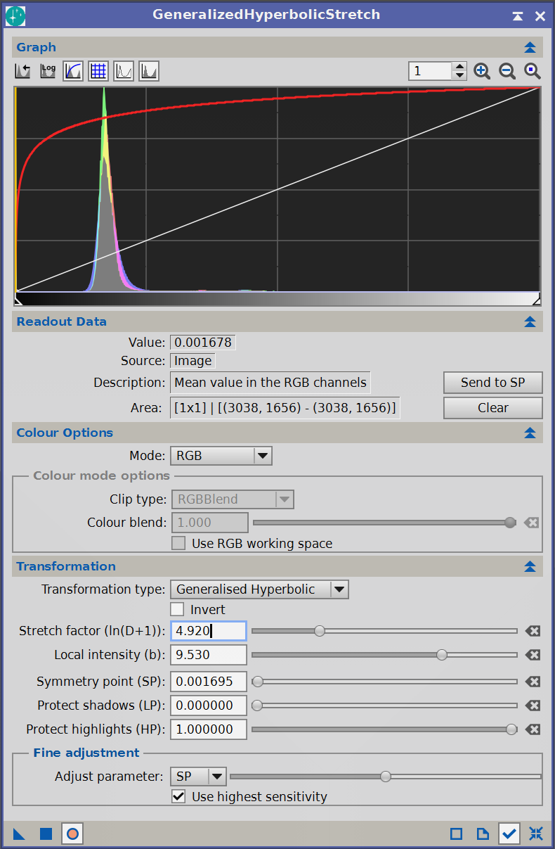
- Then click on "Send to SP" the value is automatically reported in the Transformation – Symmetry point (SP) field and in the specific Symmetry point for the Value that appears in Readout Data
- Now let's close the Screen Transfer Function using the Reset icon, the fourth last one at the top of Pixinsight the image turns black Let's open the preview and with the icon "a point in a circle" I reset the magnification of the curve. The magnification returns to "1" and only a red line that crosses the histogram window diagonally remains visible.
- Now we can start stretching by slowly varying, in Transformation, the value of Stretch factor will be seen to rise and curve the red line until it becomes vertical, while from the left comes the curve of our image
- We increase the Stretch factor until the center of the histogram curve reaches about 20% of the histogram frame and in any case until I can see all the details by slowly increasing, on the preview you can see the image appear faintly
- We increase the Local intensity value , the red curve is lowered: it must be less than 1 on the entire top, while the histogram remains in the middle of the first field on the left
- By varying the symmetry point at this time, the contrast of the image is changed. To do this, we return with the "+" icon to 250 in order to see the original position of the curves. Where the orange bar meets the red curve is the symmetry point that we can move by cursor towards the initial point of the curve, but being careful not to saturate both whites and blacks.
- We apply (square button) and Reset (button at the bottom right of GHS
- Wanting to improve the light tones a little too saturated, I go to Colour Option – Mode Colour I lower the Colour blend by adjusting it to give a slight tone without exaggerating
- Apply and reset

Let's now move on to a second step of Stretch to bring out the shadows, the method is similar.
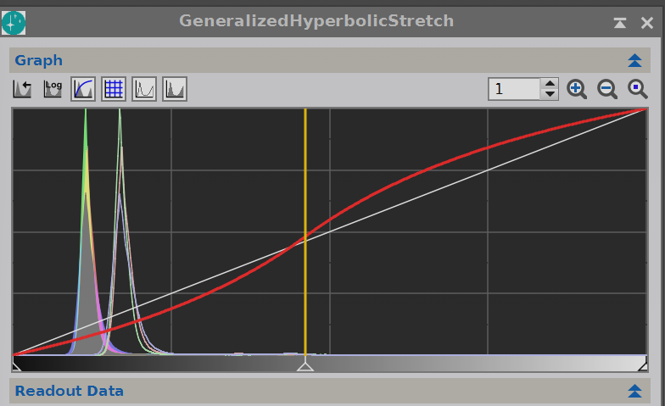
- We choose a point to improve, inside the subject the orange vertical bar is brought to correspondence
- We move the cursor from left to below this value, or just click Send to SP
- Now we can go back to stretching by very slowly varying the value of Transformation – Stretch factor until the details are visible.
- I visually adjust the sharpness of that point by varying the Transformation – Local Intensity.
- If the image becomes too dark, before entering I can still lower the Stretch factor a little and play with the Local intensity
- I adjust the highs and lows respectively using the Protect Shadow and Protect Highlights sliders so that I don't burn out the highs and lowlights. Before applying I can make adjustments to the Symmetry point and Local intensity to find the best condition. The background should not remain too black.
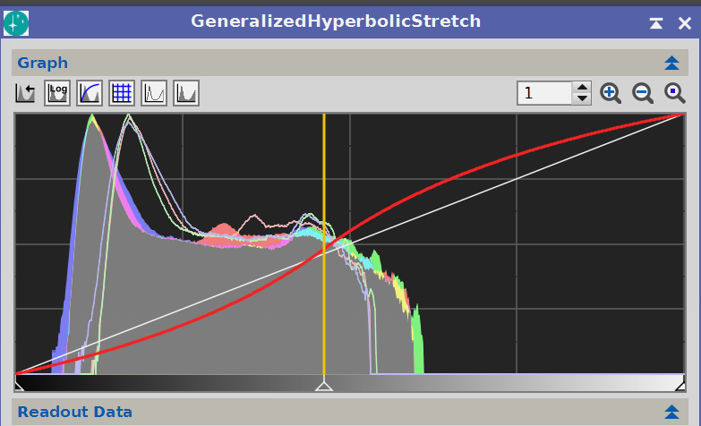
- Click on the second icon at the top, corresponding to the logarithmic display of the histogram. With this scale I can better see how each small variation in the parameters behaves. Every time I create depressions or hills, I create an imbalance between light and dark areas, that is, I create bifurcations that break down the intermediate tones, so it is a situation to be avoided. The ideal graph should show a linear descent to the right.
- Once the desired correction is reached, click on Run and reset
- Eventually we can then switch the Transformation type from Generalised Hyperbolic to Midtone Trensfer and here better adjust the midtones via the Stretch factor
- Back to the Transformation type - Generalised Hyperbolic I can go back to working on the darks and make the veils appear, we go to point the Symmetry point at a point at the left base of the histogram and do a little stretch until they appear and improve them with the Local intensity. At the moment everything seems to have worsened, but the Protect shadow and the Protect highlights I adjust and correct.

With this program we can also use other stretching methods:
- In Transformation, varying the Transformation Type from Generalised Hyperbolic to Arcsinh: the Lateral Arch Stretching, very useful for stars where it makes sense to pre-stretch before the GHS
- In Trasformation, with Linear you can:
  - By replacing the 0 of the last digit of the Low clip (LCP) with 1, giving enter the blacks become very intense, even too much (you can manually move the graph slider), but the importance is that it indicates the maximum darkness that can be obtained without cutting the darks.
  - In Blackpoint (BP), moving the slider to the left compensates for too dark Execute and exit
  - In Color Options, changing the choice in Mode it is possible to stretch only by color or by brightness or by saturation

- According to any GRADIENT CORRECTION
Repeat as needed to improve details

COSMETIC IMAGE PROCESSING

PROCESSING ON THE NEBULA

- HDR TRANSFORMATION of the Nebula
https://www.youtube.com/watch?v=cKltQhwWqEY
If you have an HDR image, you can now use the HDRMultiscaleTransform process as an alternative.
Process Parameters:
- The fewer the number of layers , the flatter the image will be and vice versa but exaggerating the result will be horrible
- Number of iterations The number of times the process repeats the iteration
- Overdrive adjusts the tripping force, basically allows you to work between 2 layer values
- Median transform leave unflagged, in some situations can improve the result
- Scaling function B3 Spline va bene
- To intensity / To lightness / Preserve hue / Lightness mask flaggare what we want to preserve
- Deringing protects images when artifacts occur
- Midtones Balance if we want to move the intervention on the histogram more towards dark tones or more towards light tones
Once you have found the best parameters, apply the process by dragging the blue triangle on the image having a 64-bit image, you can make visible the parts that initially seemed burned.
- SECOND NOISE REDUCTION of chroma on deep sky in linear
Return to see the Ctrl-K Luminance mask
Invert the area of application of the same With the top button of the Pixinsight menu icons
Apply the TGV Denoise process called Low not the most aggressive one
It is located in the Process NoiseReduction TGVDenoise menu
Process Parameters:
- Automatic Convergence Tick the choice
- Iterations 500
- Local Support Not active because we do not want to use a specific mask of it.
Let's apply the process by bringing the blue triangle to the image. The script will create the masks and apply the processes in sequence, first TGV Denoise and then the Multiscale MT.

Note: Alternatively, noise reduction with Multiscale Linear Transform by activating the Noise Reduction item for all layers and setting a Treshold value for each layer that decreases from the first to the last layer: e.g. 1500 the first; 1100 the second and then 0.7; 0,3; 0,2

We unapply the mask via the X icon on the Pixinsight menu bar
- the labella is no longer brown but gray, so the mask is no longer applied,
- We keep the preview because we can still need it.

- INCREASE CONTRAST IN DARK AREAS
It is used to improve the dark areas of nebulae, accentuate the areas of gas
Aprire lo script Dark Structure Enhance
Si trova in Script > Utility > Dark Structure Enhance
- Iterations Leave at 1 so as not to overdo it
- Amount set to a 20% (0.20) - If I want to enhance the blacks I can also increase it, but without exaggerating otherwise they become too deep
- Mask Parameters come di default
The script is executed by giving the OK

- A SLIGHT HDR always to accentuate the gas areas
Open the EZ HDR script and apply the script using Run EZ HDR The script ends with our mixed image, plus the mask where it worked and the harder very exaggerated HDR image it used (we can see it via the monitor icon on the menu bar).
- HDR Blend 0.30 (0.25 – 0.30 are standard values)
- HDR Layers 7
Run the script Continue with our image, close the other two

- IMPROVE NEBULA COLOR CURVES
Open the Curve Transformation process Apply the Preview
- RGB create a slight S-curve (lowering dark areas and raising treble) to increase contrast
- Saturation I apply a minimum of saturation
- Apply with the square key, then close Process and Preview

- IMPROVE CONTRASTS of the light areas of the nebula
It is performed with a luminance mask or with a Range Mask applied.
Open the Local Histogram Equalization process Acts on the histogram in the area that is not protected by the mask.
Si trova in Process > Intensity Transformation > Local Histogram Equalization
Clicking on the blue circle at the bottom opens a real-time preview where you can see the changes by changing the parameters
- Kernel Radius 60 - A high value softens the image; a low value makes the contrasts harsher
- Contrast Limit Set around 1.5-3.50 (maximum 3.5 – 4.0)
- Amount This is the percentage applied by the process 200% (maximum 0.300 otherwise beyond that artifacts come out)
To improve burnt parts, increase the Contrast Limit and decrease the Radius Kernel.
Very common nebulae in which there are no burn problems can be climbed with the Radius Kernel.
In galaxies and where you want to get a stronger contrast the Kernel Radius lowers around 50 which gives much more aggressiveness.
Apply the process using the square button, close process and preview.

- DARKEN THE BACKGROUND OF THE SKY if necessary
Invert the area of application of the Range Mask
Open the Curve Transformation process again and open its preview
- RGB create a slight S-curve to darken the sky
- CIE *L component (Lighteness) I apply a curve to reduce the brightness of the sky
- Apply with the square key
- Close Process and Preview
- Staccare la Range Mask
Detaching the Range Mask from the image We deapply it via the X icon on the Pixinsight menu bar and keep it, it can be used in other situations, e.g. if I want to change some parameters only on the nebula or only on the background sky.

- ADJUSTING THE COLORS of the nebula
With the different color masks: RedMask, CyanMask, etc., we will create the masks of each color. To obtain them, just drag the Mask of the chosen color onto the image.
The mask of the area affected by the chosen color is created each time On this I drag the Mask Blur above, even several times, to soften the affected area, or I open the Mask Blur process by changing the "sigma" value and then I apply it.
Mask Blur is a PixelMath-based process that creates a Convolution, which is the opposite of the previous Deconvolution.
When the mask has reached the conditions we consider best Drag the mask Label onto the image Label using Ctrl+K it is possible to hide or revise the applied mask.

With Histogram Transformation we can adjust the histogram, both of the image and of the masks created.
I open the preview with the blue circle button and start moving the cursors by eliminating the useless parts of the histogram, being careful not to affect it: in the "Shadows" field I read the cut pixels. Starting with the midtones, then the dark tones and then again the midtones and light tones, applying with the square button and resetting each time.

With Clone Stamp we can darken the areas not of interest, present on the masks

- CORRECTING NEBULA COLORS
First you make a general correction with no masks applied
- Open the Curve Transformation process Call up the Preview to adjust the color curves
  - First with RGB/K a little curve to increase the contrast (I lower the dark tones and raise the high tones).
  - Then with S increase the saturation a little

Note: By touching the parts of the image, on the graph you can see the lines corresponding to the positions on the graph. If you want, you could then change the individual positions.

Then apply the masks and correct the colors You generally start with the mask of the color RED by making the following adjustments:
- on the color R I raise the curve of the color to enhance it
- Enhance contrast using the complementary color For Red, use the complementary Green by creating an S-curve by lowering it to the right and raising it to the left.
- on the "C" color to increase it a little
- on the "S" saturation also increasing it without exaggerating (alternatively you could use the Color Saturation process)
I can always see the difference between before and after via the blue circle symbol on the preview,
When I am satisfied I apply it using a square button and as always after I reset.

I apply the cyan mask (even without closing Curve Transformation, but only by restarting the preview):
- with the "B" I go down a little, small variations without exaggerating (go up to enhance the yellows and greens, go down to go on the blues, purples, blues)
- with the blue color increasing a little to enhance it
Always apply reset every time
Note: This method applies to all the masks that are to be applied from time to time.

- ALTERNATIVA: USARE LO SCRIPT SELECTIVE COLOR CORRECTION
With the Selective Color Correction script (found in Script > Toolbox > SelectiveColorCorrection) you can adjust the colors by creating masks within the script through the setting parameters, or you can import and use your own masks created in the different color masks: RedMask, YellowMask, etc. by then adjusting the setting parameters within the script. Through "Show mask you can see the mask created/modified by the script.

- REMOVE COLOR DOMINANCE
With the SCNR process it is possible to remove any dominances: normally green, but from the shortcut curtain you can choose blue or red.

- INCREASE CONTRAST IN DARK AREAS
Apply the Dark Structure Enhance script, repeating process 33 If necessary , it is used to increase the evidence and contrast of the dark nebulosity areas
Remove the mask At this point the photo of the nebulous part is finished, now let's work on the stars.

- IMPROVING AREA TOO LIGHT – BURNT
Starting from the narrowband luminance mask B_L, with Histogram Transformation I darken until only the most burned area is visible, then with Range_Selection I create the Range_Mask of the area.
I apply the Range Mask both to my B image and then to the RGB image, with Curve_Transformation I go to lower the lighter parts in RGB trying not to get to grayish. Maybe even giving a little C color.

- BRINGING NEBULA AND STARS TOGETHER
Change the name of the RGB image with stars, calling it "STARS" (all in capital letters because that's how it is called in the PixelMath Starless with STARS process)
Start STARLESS WITH STARS a formula in Pixel Math with Expression Editor we write Image Name + STARS.
  - The expression creates the medians of the two images and sums them so that the stars are not oversaturated.
Check the Create new image item and on Image Id we mark the name we want, e.g. NGC281 Pacman
Start the process Drag the process with the triangle onto the image of the Nebula.

- SLIGHT REDUCTION OF STARS
Opening the EZ Star Reduction script requires it to create a mask on the stars -> Create Star Mask for Reduction
If he does not create it, in Raw StarNet Star Mask we indicate the mask to be used In Raw StarNet Star Mask -> indicate the file STELLE_L
Star Reduction iterations Reduce the value if it has reduced the stars too much
Giving the Run script does the reduction of the stars so they become much smaller.

Note: Certainly even better is to make different exposures during the shooting phase: using a much shorter time for the stars which thus become less saturated, and do not lose their color, compared to a longer time to photograph nebulae. The too much saturation of the stars means that they lose their color and become white and even more swollen.

- DARKEN THE BACKGROUND AGAIN
Starting the process ArcsinhStretch_fondo sky, acts only on the background sky and not on the subject.
Si trova in Process > Intensity Transformations > ArcsinhStretch
Open the preview in real time
- Flag Protect highlights and Use RGB working space
- If you want, you can also flag the Highlight values clipped to zero which highlights the changed values
- Click the Estimate Black Point The process makes an automatic adjustment of the blacks: if it seems too much you can change it using the cursor.
- Warning: If you make it too black, details of the gases around the nebula are lost.
Apply the process and reset

- LAST POSSIBLE NOISE REDUCTION
If you still want to remove the noise TGV Denoise Low
- Always do a Preview to see the effect of the interventions
Close both the preview and the process and the image is finished.

- COPYRIGHT
Open process FITSHeader to see the data that the astronomy camera has written in the file and enter the Copyright
Located in Process > Image > FITSHeader
Name Indicate your name or any Nickname
Value Indicare “T” (True)
Comment Indicare “ALL RIGHT RESERVED”

Note: If you want to transfer the data written to the source image in the final image, open the source image and read the recorded data, then drag the blue process triangle onto the final image. The data will now be available.
At the moment I don't know how to add data from 2 different images because each time the new data replaces the previous ones

Alternative: SCRIPT> RENDER> DRAW SIGNATURE to write text on the image

- IDENTIFY STARS AND NEBULAE with image annotation
Aprire lo script Annotate Image
Si trova in Script > Astrometry > Annotate Image
- Layers Add the catalogues of interest with the "+" symbol or remove them with the "X" symbol according to the desired annotations (Gaia has too many stars, fills the whole screen with writings, add NGC-IC, LDN, LBN, etc.)
- Show Markers Adjust the color you want for the markers
- Show Layers Adjust the color you want for annotations
- General Properties remove flag d Apply STF before annotation (the image is already stretched)
- Observation Indicate the date the image was taken
  - in the case of an image derived from grouping images with different shooting dates, indicate at least one of their dates
Execute the script using the "OK" button The annotated image will be created
If the script does not work, e.g. for a cropped image, run the Image Solver script as per Step 11"

- ANNOTATE ON THE IMAGE
If you want to write to the image, open the Annotation process
Si trova in Process > Painting > Annotation
Under Text indicate how much you want to write
By ticking the Show Leader item, a line with an arrow will indicate the subject you have written down
In the Fonts section you can choose the font characteristics you want
Start the process Drag the blue triangle on the image If the text you want does not appear, redo ImageSolver
Drag the text to the desired position Press OK with the green checkmark

- SAVE IMAGE
With FILE Save As you can save the image in the following formats:
- XISF if we want to use it in subsequent processes, (you can make versions with the channels disconnected, then the version in HO or Hubble Palette with normalization processes, using color masks, etc.)
- 16-bit TIFF Pixinsight saves it at 32-bit by default but it's not good. For any subsequent processing in Photoshop you need to save at 16-bit.
- Jpeg for all other uses.

- INSERT A LOGO OR GRAPHIC WITH PHOTOSHOP
Open the saved image
Open the image with the logo to be added Go to Layers (menu on the right) and open the context menu (icon with the 3 dashes) duplicate layer
In Destination, I choose the image I want to add the logo on
I go back to the image I want to add the logo to and I will find the duplicate layer, in very large size Ctrl+T to select the logo
Drag by means of a side handle until it reaches the desired size, then move it to the desired position
If I want the logo to be less noticeable, I go to the levels menu and decrease the opacity

If I want to add text, I go to the Text icon "T" I choose the font and other characteristics of the text
I click on the image and create an area where I write the desired text with the handles I can enlarge the text area
With the Move tool (symbol 4 cross arrows) I move the text to the desired position
If I want the text to be less obvious, I go to the layers menu and decrease the opacity I can add the shadow effect
When the logo/text is in the desired condition, select the layers from the Layer menu and choose Merge Layers
Save the image
See also the video https://youtu.be/ylUu9CMXZJ0

- INSERT A LOGO OR GRAPHIC WITH LIGHTROOM
Steps:
- Import the JPG image into Lightroom (Classic or Cloud).
- Edit the image if necessary.
- Go to File > Export.
- In the export window, look for the "Watermark" section.
- Tick "Apply Watermark" and click on "Edit Watermarks..." (Edit Watermarks...).
- The watermark editor will open:
  - You can choose between text or image.
  - For logo: Select "Graphics" and upload your PNG or JPG file of the logo.
  - By text signature: write the text and choose font, size, opacity, position etc.
  - A logo in PNG format with a transparent background is recommended.
- Place the watermark in the corner of your choice.
- Give the preset a name and save it.
- When exporting, select that preset to automatically apply the signature/logo.
  - You can save multiple presets for different signatures (e.g., vertical, horizontal, light, dark).
  - You can't directly edit the content of a JPG that has already been saved with a watermark — you need to export again from Lightroom with the watermark applied.

Between the two methods, if you need to do it on a single image in a creative way, it is better to use Photoshop, which allows you to:
- Manually position the logo.
- Adjust opacity, blending, shadow, etc.

TECHNIQUES FOR WORKING WITH MOSAICS or/and DIFFERENT FILTERS
Below, to explain how to work with mosaics and filters, reference is made to a practical example with the various phases that can be followed, but everyone can then adapt the flow according to their subject, their images, etc.
The explanation of the phases already covered in the previous paragraphs obviously I have not repeated it again.
F will be used to indicate that what is written is valid in the post-production of images made with different filters; P to indicate that it is valid for Panels and F/P when it is valid for both.
Many processes do not need explanation beyond what has already been written in the previous paragraphs

- IL SUBFRAME SELECTOR; F/P
The Subframe Selector process does not change from what has already been explained in the "Deep sky astrophotography processing" handout. The only thing to keep in mind is that the Subframe Selector process must be executed for each group of lights, i.e. for each panel or/and for each filter.
Therefore, when you want to start doing more complex processing with mosaics and filters, you have to think according to what will be the subsequent WeightedBatchPreprocessing (WBPP) process.
To explain this, we first need to understand how the WBPP works: once the script is opened, on the right there is the Grouping Keywords area. If flagged, it tells the script to group the frames according to a Key, which can be "DATE", "FILTER" or whatever you want.
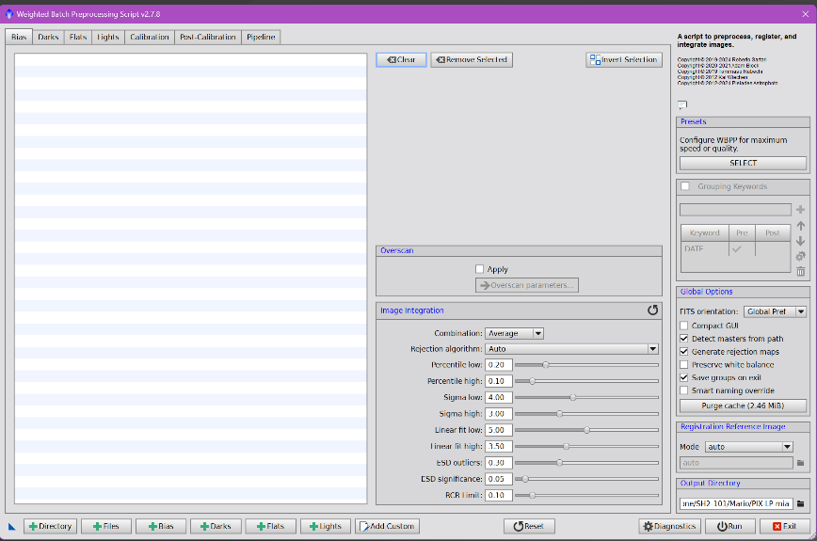
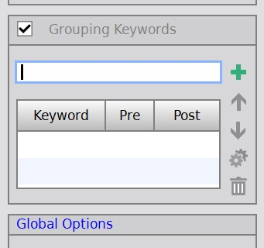

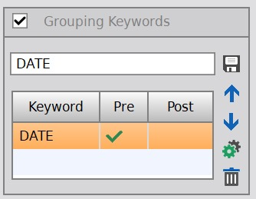
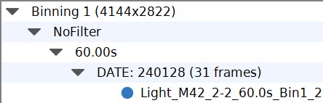
For example, having indicated "DATE", the script groups the frames by shooting date

The best thing is therefore to work in an orderly way, once I have created the working folder of the object, in it I create folders according to the result I want to obtain. In this way you are sure to associate the correct flats with the relative lights, etc.
The simplest case is when you want to obtain an image made up of lights made on different dates.
Once the subject's folder has been created, as many folders must be created in it as there are shooting dates. These folders, if "DATE" is the desired key, must have the name "DATE xxyyzz" where xxyyzz will be the shooting date (e.g. "DATE 240114").
In each of them I then put folders and files of the Light and Flat, and I also create the PES folder where I save the files created by the Subframe Selector.
Es. di directory:
M42

DATES 240114 DATES 240816 DATES 240818
Light Light Light
Flat Flat Flat
PES PES PES
PIX
Similar situation when you want to obtain an image made up of lights made with different filters, instead of DATE there will be FILTER
In the subject's folder, the "FILTER" folders must be created. These folders must therefore have the name "FILTER xxx" where xxx will be the name of the filter (e.g. "FILTER LP", "FILTER LE").
Similarly in each of them I then put folders and files of the Light and Flat, and I also create the PES folder where I save the files created by the Subframe Selector.
Once the Grouping Keywords area has been flagged and "FILTER" as the keyword, we will have to create the appropriate folders.

Es. di directory:
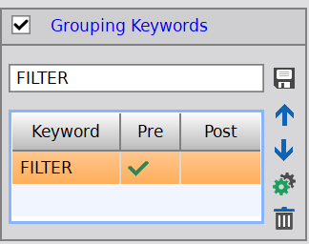
M42

FILTER LP FILTER LE
Light Light
Flat Flat
PES PES
PIX
The situation becomes more complex when you want to create an image consisting of e.g. 4 panels whose lights were created on different dates. In this case the Grouping Keywords becomes more complex and similarly the directories become more structured, but good planning makes the work easier with correct results.
Using the gear icon you can choose whether each keyword should work in Pre or Post Process.

Es. di directory:
M42 Panel
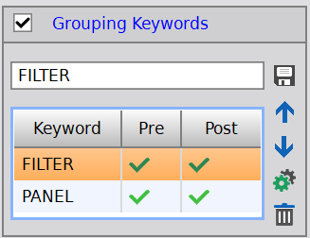
FILTER LP
(long band)
PANEL 1 PANEL 2 PANEL 3 PANEL 4
Light Light Light Light
Flat Flat Flat FLAT
PES PES PES PES

Pix_P1 Pix_P2 Pix_P3 Pix_P4
(P1_ra.xifs) (P2_ra.xifs) (P3_ra.xifs) (P4_ra.xifs)

FILTER LE
(band Stretta)
PANEL 1 PANEL 2 PANEL 3 PANEL 4
Light Light Light Light
Flat Flat Flat FLAT
PES PES PES PES

Pix_P1 Pix_P2 Pix_P3 Pix_P4
(P1_ra.xifs) (P2_ra.xifs) (P3_ra.xifs) (P4_ra.xifs)

- IL WEIGHTED BATCH PREPROCESSING; F/P
Once the WBPP script has been opened, once the situation of the frames to be processed is clear, you can proceed to load the frames into the LABELS exactly as explained in the "Deep sky astrophotography processing" handout.
As indicated above, we put the flag on Grouping Keywords and enter the desired Keyword(s) defining whether they should be considered in Pre or Post Process.

- IL WEIGHTED BATCH PREPROCESSING; P
In the specific case of mosaic processing, in the Light label it is necessary to remove the check from Image Integration - Autocrop because autocrop should never be performed with mosaics.
Each wideband panel must correspond, in size and shooting angle, to the corresponding narrowband panel (e.g. P1 with P1, etc.), so in Registration Reference Image instead of leaving Mode Auto now choose Mode Manual and then go to indicate a PES reference image: for all panels the same PES image taken from the PES images of one of the filters is used. The resulting images will therefore be perfectly superimposable.

Note: Normally Shooting The broadband filter is used to image the stars, while the narrowband filter is used to image the color of the nebulae.
So with the narrowband filter that lets much less light through, I make much longer exposures, e.g. 300/600 sec., while with the broadband filter, since more light arrives, it is preferable to do the exposures with very short shutter speeds: e.g. 60 sec., this is also so as not to have too big stars.
Note: In the case that you want to keep the color shot in broadband (as perhaps some subjects have reflection parts that are cut off by the narrowband filter), it is customary to take three types of shots:
- a broadband series for stars with short times e.g. 60 sec,
- A broadband series for color e.g. 180 seconds
- plus the narrowband series at 300/600 seconds
After making the mosaic of the two series: the broadband one private of the stars and the narrowband one also deprived of the stars, they will have to be processed to be added together.

Now I open the 4 panels created for each filter and continue the processing in parallel: Narrowband and Broadband, P1 with P1; P2 with P2; etc.

- LINEAR PHASE PROCESSING; F/P
I make each panel the STF without concatenation
If the images have no noise, I don't do PixelMath B-R

- EQUALIZE LUMINANCE; F/P
RGB Working Space port on each panel

- GRADIENT ELIMINATION through Gradient Correction; F/P
I drag the Gradient Correction to each Panel

- COLOR CALIBRATION; F/P
We perform the Spectro Photometric Color Calibration process for each Panel where we have created a different preview area on each Panel. If I used a single preview for all the panels I could create color distortions.

- NOISE REDUCTION; F/P
Do EZDenoise on each Panel

- EQUALIZE THE IMAGES OF THE PANELS (still in linear phase) ; F/P
To do the equalization you have to use the DNALinearfit script. It is used to uniform the brightness of the panels.
- Reference View For each filter, a reference image is taken: the one that appears with the best colors
- Target View I point to the other images one at a time
- LinearFit Method va bene Mean/Median
- Reject High 0,92 come di default
By giving the OK, the images that will form the panel are equalized with respect to the reference one
After each EQ:
- I remove the STF, I reset it monitor icon
- I remake the penultimate STF icon, with radioactive symbol.
- ALIGN THE PANELS TO MAKE THE MOSAIC: P
To put the panels together, align the images with each other, the MosaicByCoordinates script is used as it performs the creation of the final image, following the astrometris of the individual panels.
The script is located in Script > Mosaic > MosaicByCoordinates
- With Add Windows I add the panels that I have open to the screen
- Projection must be active with the "Mercator" function
- Center coordinates and other items Uncheck
- In Interpolation, Pixel Interpolation Auto
- Clamping Threshold 0,30
- In the Output Images directory, specify the directory where you want to save files with the suffix _ra
- Give the OK Run will indicate that rather large images will be created
The execution creates new still black pins apply STF via radioactive symbol icon to see the result
Using the monitor icon, remove the STF from each panel _ra the images turn black
Redo the stretch via radioactive symbol icon the stretch is now updated

- IMAGE STRATCHING; F/P
The aligned images before saving them must be strictly stripped. It can be done with the special HT Stretch Linked RGB script or with Histogram Transformation
Once stretched, save all _ra panels in *.xisf format

- FUSE THE PANELS TOGETHER: P
To create the final image you need to use the GradientMergeMosaic process
The process is located in Process > GradientDomain > GradientMergeMosaic
- ADD Add saved panel files
- Type of combination Overlay if it is a nebula
  - Average if it is a galaxy
- Shrink radius 5 which is an ideal average value
- Feather radius 20 is normally fine
- Black poin leave at 0
- Generate Mask leave unchecked
Giving the OK via blue dot creates the unique image of the 4 panels, if the options are correct they do not see gaps between panels, otherwise it can be corrected by changing the parameters a little.

- DYNAMIC CROP of the resulting panel; P
Use the Dynamic Crop process to define the usable area of the image

- IMAGE SOLVER OF THE IMAGE; F/P

- AESTHETIC PROCESSING; F/P
Duplicate the image and call it RGB, the other copy we rename B
We will work the stars from RGB

- MASKING STARS; F/P
Image B Run the Process Starnet2 the Star Mask is created, color image
Perform Star Mask Luminance (Star mask L) Horizontal Color Bar Icon
- ELIMINATE any STAINS if present on the part of the deep sky; F/P
Perform the Clone Stamp on Image B

- Deconvolution of the Nebula; F/P
Extract the luminance mask of image B and treat it with Histogram Transformation up to the middle of the peak and then go up with the midtones Apply it to image B and then proceed with Deconvolution 294 Panametric

- LOCAL HISTOGRAM EQUALIZATION; F/P
It is performed with a luminance mask applied

- A SLIGHT HDR again to accentuate the gas areas with the EZ HDR script; F/P

- POSSIBLY increase the CONTRAST IN DARK AREAS; F/P
Runs with the Dark Structure Enhance script

- ADJUSTING THE COLORS of the nebula; F/P
Masks are usually made for red and cyan colors, softened by MaskBlur

- CORRECTING NEBULA COLORS; F/P

- IMPROVEMENT OF THE AREA TOO LIGHT – BURNED; F/P

- PROCESSING ON THE STARS RGB image; F/P
Any spots on the background sky are of no interest here because the background sky will be darkened

- DARKEN THE BACKGROUND SKY; F/P

- MERGE B and RGB CHANNELS; F/P
Starless_Stelle_RGB_Fusione is used whose formula is:
.symbols m=0.7;
~(~$T*~mtf(m,RGB));

Note: in the pixelmath script "starless rgb merge" in Destination the "Create new image" option must be flagged, otherwise the merging of the channels takes place on the image you are using by default which becomes definitive preventing you from performing any further tests.

The execution of the script is done by dragging the blue triangle over image B: in practice the script combines 70% of B and the rest of RGB.
Depending on the result I can vary the factor 0.7 bringing it perhaps from 0.5 to 0.8 depending on how I like it and I do many tests until I reach the most pleasant result
HDRComposition is used to combine images taken with different times and in the case of nebulae with burnt areas, it allows you to mitigate this defect while maintaining the details otherwise not visible

- DARKEN THE BACKGROUND OF THE SKY AGAIN with ArcsinhStretch; F/P

- IDENTIFY STARS AND NEBULAE with annotation on the image; F/P

- EDGE CROPPING using Dynamic Crop process; F/P
To make 2 cropped images in the same way, once the process is open you need to:
- Adjust the area to be cropped using the sliders in the center of each side The values in Size Position adjust
- Do not apply the process yet or else it loses the crop data
- Save the process to the work area, dragging the blue triangle over an image-free area will form the cropping process icon
- Now drag the icon created, which has kept the cropping data, on the images you want to crop they will be cropped in exactly the same way

TENICA DEL CONTINUUM SUBTRACTION
Continuum Subtraction isolates the pure narrowband signal (such as H-Alpha or OIII) by removing the "continuous" background light of stars and galaxies. This prevents color casts and star enlargement when combining narrowband with RGB broadband data
Continuum subtraction: this is done in the processing of galaxies, those that are NOT edge-on. Galaxies emit all the light, but they can have nebulae inside.
For galaxies, only the red channel of the narrowband will be held
Subtraction of the continuum: it is performed in the processing of nebulae, especially dark or reflection. Normally they are done at broadband but it may make sense to add narrow band (e.g. even the Pleiadise taken from a very good sky)
Subtraction of the continuum: in the Halfa there is Halfa + everything that is red by nature: dust, stars and interstellar medium
Narrowband halfa + wide band = strong red dominant and balloon stars, so it is necessary to clean Halfa from the red continuum, i.e. non-Halfa red
It must absolutely be done in a linear phase. I will have to relate Halfa to the red

For a well-done continuum subtraction, the fundamental rule is: RGB wideband and narrowband images must be in the same photometric processing state, but still linear.
The recommended sequence is:
1. Preprocessing completo:
- WBPP con ImageIntegration, LocalNormalization (se usata), Drizzle (se usato)
You get:
- MasterLight Banda Stretta
- MasterLight RGB Long Band

2. Gradient correction → YES, to be done on both masters before channel extraction.
Reason: If the gradient remains in the continuum, when you subtract the R channel of the L-Pro, you are left with artificial residues.

3. SPCC → YES
This is also before continuum subtraction because subtraction works best when the Broadband R channel and the Narrowband R channel have a consistent photometric calibration.

4. Noise Reduction → NO and do not merge color channels (STF)
It is not to be done first because noise reduction changes the pixel values.
If done before subtraction, the scale coefficient no longer correctly represents the continuum.

Channel extraction
From the narrowband Halfa+ O iii the channel R must be extracted which represents the narrowband Halfa signal
In the broadband part I will have to use the R channel to relate it to the R of the narrowband

1. Pull the R channel out of the L-Pro master
Open the linear L-Pro master and use:
Process → ChannelManagement ChannelExtraction
Modalities:
- RGB
- Extract Red
You will get a new image, for example:
R_LPro
This will be your red continuum.

2. Extract the Ha channel from the NBZ master
With an OSC the NBZ filter records:
- Hα mainly in the R channel
- OIII in channels G and B
So:
ChannelExtraction → Red
from the NBZ master.
You will get:
HaNBZ_raw
In reality, it is not yet pure Hα: it contains
- Hα
- Red Stellar Continuum
- some residual broadband signal
Precisely what we want to eliminate.

Ha and R image processing
Before doing the Continuum Subtraction (Ha - 0.15*(R - med(R)) the two channels should be normalized to each other.
For example, if channel Banda_Stretta_R has a median of 0.020 and channel Banda_Larga_R has a median of 0.003, then the Continuum Subtraction math subtracts very little. Conversely, if channel Banda_Larga_R is much stronger than channel Banda_Stretta_R, subtract too much.
Open:
Process → ImageInspection → Statistics
and measure:
- median di Banda_Stretta _R
- median di Banda_Larga _R
If the Banda_Stretta_R to Banda_Larga_R ratio differ by a factor of 2, 5, 10 or more, normalization must be carried out.

Simple method: normalization using median
A practical explanation is simpler: open Statistics and note the median of both.
- median di Banda_Stretta _R = 1076,498
- median di Banda_Larga _R = 91,579
Let's calculate that 1076.498 / 91.579 = 11.75486
So through PixelMat we bring Banda_Larga_R on the same scale as Banda_Stretta_R:
- Banda_Larga_R * 11,75486

Note: PixelMath wants "." (period) in place of the "," (comma)
Note: To have PixelMath generate a Gray image (1 channel), in PixelMath, in the Destination section (bottom of the window):
- Create New Image = ON
- Color Space = Grayscale
- Sample Format = Same as target (o 32-bit float)
- and above all Disable: Use a single RGB/K expression
- or, in newer versions: Generate RGB image (must be disabled).

Best Method: LinearFit
Process → ColorCalibration → LinearFit
How to use it
- Open Banda_Stretta_R and Banda_Larga_R.
- Apri LinearFit.
- Imposta come Reference image: Banda_Stretta_R
- Drag the LinearFit triangle to: Banda_Larga_R
You will get a Banda_Larga_R_fittata, i.e. scaled to have an intensity distribution compatible with Banda_Stretta_R.
Now we can continue with Finding a pure Ha that is the Continuum subtraction

Finding a pure Ha
However, there is a very important detail: the R channel of the Narrow Band is not pure Hα but contains a small amount of residual continuum and the coefficient k is often not constant over the entire range.
This residue can be removed manually using PixelMath or through the special PhotometricContinuumSubtraction (PCS) process that automatically calculates the scale coefficient without doing manual tests.

Method via PixelMath
With PixelMath I can do Ha-k*(R-med(R)) or: It has narrowband – the red R of broadband from which I remove the median of the red R of broadband (R is the red signal of broadband).
The median of the broadband red represents the background red information.
I have a pure red signal deprived of the red of the background sky. Using the coefficient k, I subtract the red from the Halfa, (K is a constant to be found in the correct value from time to time).

Finding the correct value of k
It is the most important step.
For example, for the IDAS NBZ + Optolong L-Pro filter with a modern OSC chamber we often start with:
k = 0.10
and then you try:
0.08
0.10
0.12
0.15
until the stars almost disappear but no black halos appear.
If black stars or/and hollowed out areas appear, you are oversubtracting.
If, on the other hand, the stars remain very evident, k increases slightly.
Result
You will get Ha_pure that represents the almost pure Hα signal.

ALTERNATIVE More modern method
In recent years many PixInsight users have been using the script: PhotometricContinuumSubtraction (PCS) which automatically calculates the scale coefficient without doing manual tests.
You give him:
- Narrowband master still linear
- Broadband Master - Linear
and he directly produces the Hα channel with the continuum removed.
The resulting Ha channel will be horrible, you have to do many tests before you have a valid result, all ruined, noisy, stained black, but a channel like this most of the time is fine
Everything that black is protected later when we add it.
All that is clear, it will then suffer the increase of red from the contribution of the Halfa
In some cases it is very nice to make Oiii to be added to broadband: for example M33 where narrowband serves both Halfa and Oiii to be added to broadband
Of the nebulae, the Squid / Squid if we take it a little wider there are the dark areas of the Seahorse: narrow band for the squid but broadband to take the whole area.
If for the Halfa we used the red channel, for the Oiii which is a little green and a little blue, in this case the subtraction of the continuus I will have to do with a synthetic channel that derives from the average between green and blue, that is, with blue + green divided by 2 but of the broadband, more complete band than the narrow band.

APPLICAZIONE RAPIDA alternativa PhotometricContinuumSubtraction -- Fully Automatic Subtraction
https://www.youtube.com/watch?v=fCeNtYF50OA
The quickest, most accurate, and most automated way to do this in PixInsight is to use the Photometric Continuum Subtraction (PCS) script.
Preparation: Make sure your images (narrowband and broadband masters, e.g. H-Alpha and Red/Green) are linear, with gradients removed and edges cropped.
Execution: Go to the Scripts menu > Night Photons > Photometric Continuum Subtraction (or search for "Continuum" in the Scripts menu).
Settings: Select the narrowband image as the Narrowband Input (e.g., H-Alpha) and the corresponding broadband image as the Broadband Input (e.g., Red). Tick the option to generate starless images (Generate Starless) if desired.
Output: The script will automatically calculate photometric weights and generate separate images without continuums, ready to be processed and merged.
Alternative methods (Native and classic scripts) If you prefer to combine H-Alpha images (or other channels) directly with your RGB data without going through the dedicated script, PixInsight offers native tools:
NBRGBCombination: It is located in Scripts > Utilities and is the classic script integrated into the program to create HRGB images in a controlled way.
PixelMath: The traditional manual method consists of aligning the images, normalizing the background with BackgroundNeutralization, and subtracting the continuum signal (e.g., from the red channel) from the narrowband image using a mathematical expression.

After obtaining Ha_Puro with the subtraction of the continuum, the fundamental step is:
return Ha_Puro to the scale of the R broadband channel before re-injecting it into the RGB.
With my numbers:
- RGB_R ≈ 91.6
- NBZ_R ≈ 1076.5
Ha_Puro was born on a scale close to that of narrowband (≈1000), not broadband (≈90).
Therefore, it is not convenient to do directly:
R_New = RGB_R + 0.10*Ha_Puro
Because even 10% of an image with ~1000 scale can be too much.
Best Method: LinearFit
- Usa LinearFit.
- Reference image = RGB_R
- Target image = Ha_Puro
You'll get a new Ha_fit with levels compatible with broadband red.
Then:
R_New = RGB_R + 0.10*Ha_fit
or more conservative:
R_New = RGB_R + 0.05*Ha_fit

Manual method
If you want to do everything in PixelMath, you can scale Ha_Puro with the ratio of the medians:
$$f=\frac{91.579}{1076.498}≈0.085$$
therefore: Ha_fit = Ha_Puro * 0.085

and then: R_New = RGB_R + 0.10*Ha_fit

which is equivalent to: R_New = RGB_R + 0.0085*Ha_Puro
Do you notice how the actual coefficient becomes very small? This is normal because Ha_Puro was on a scale about 12 times higher.

For your future workflow
With the setup I use (narrowband filter + wideband filter):
- Estrai R from RGB.
- Scale R to do continuum subtraction.
- Calculate Ha_Puro.
- Rescale Ha_Puro to RGB_R (LinearFit).
- Build:
R_New = RGB_R + w*Ha_fit
with w between 0.05 and 0.30 depending on how much you want to emphasize the Hα.
6. ChannelCombination con:
- R = R_New
- G = RGB_G
- B = RGB_B
This completely avoids the problem of the dominant red you saw. It also allows you to adjust the intensity of the Hα in a predictable way: you only change w, without altering the color balance of the RGB.

TECHNIQUES FOR JOINING COLOR CHANNELS
Once the mosaic of starless nebulae in narrowband and the analogue in RGB broadband have been made, they must now be processed to be added together. This is normally done with stretched images, but it can also be done with images that are still linear. To do this there are several methods:

- First method
The first method, the simplest but also the least effective, is to make a simple sum in PixelMath:
- 0.5*RGB+0.5*Banda_stretta
- Destination Create new Image
A percentage of the two panels is used because if I applied a simple sum it would result in a whitish image

- Technical S
As a second technique, based on PixelMath, PixelMath_Ha is used whose formula is:
- HA-0.6*(RED-MED(RED))
This script only takes into account the red of both wideband and narrow web panels because red is normally decisive in the aesthetics of the image.
Split the channels of both narrowband and broadband:
- I rename HA the red of the narrow band
- I rename the red of broadband RED
- I rename the green of broadband GREEN
- I rename BLUE the blue of broadband
- Destination create new image
The script, based on the percentage (e.g. 0.6) indicated in the formula, applying the process with this expression will make an implemented average of the broadband red with the narrow band red.
Tolta la spunta da Use a single RGB/K expression,

- Other technique
Another technique, also based on PixelMath, is used Starless_Stelle_RGB_Fusione whose formula is:
- .symbols m=0.7;
- ~(~$T*~mtf(m,RGB));
It is used to join the nebula made in narrow band with the stars taken in broadband
I drag it over image B and basically merge 70% of B and the rest from RGB.
Depending on the result, I can vary the factor 0.7, perhaps bringing it from 0.5 to 0.8 depending on how you like it
The advantage of this technique is that the stars are smaller, because they are used only in percentages, without changing the color

- Other method
If you created for example:
Ha_puro = HaNBZ_raw - k*(R_LPro - with(R_LPro))
then Ha_puro is already the Hα signal (or an estimate of it) with much of the continuum removed.
To integrate it into RGB you don't have to do:
R_new = Ha_puro + R_LPro
at 1:1 weight, because you would end up doubling the red.
Usually a controlled mixture is made:
R_new = R_RGB + a*Ha_puro
where:
- R_RGB = red channel extracted from your RGB L-Pro
- Ha_puro = result of continuum subtraction
- A = Reinforcement Factor
Typical values are: 0.10 - 0.15 - 0.20 - 0.30
But I would start from low values: R_new = R_RGB + 0.10*Ha_puro

Integrate Ha_Puro into RGB_R
Safe method:
- Open PixelMath and type: RGB_R_Norm + 0.10*Ha_Puro
- In the options:
  - Create New Image = ✓
  - Color Space = Gray
  - New Image Id = Rnew
- Drag the triangle over a gray image, such as RGB_R_Norm.
The result should have in the title:
Rnew
Gray
and immediately appear in ChannelCombination.

- An additional technique
A further technique is to use a Pixinsight script called NRGBCombination
Lo script si trova in Script > Utilities > NRGBCombination.
The script can be used after having:
- Duplicated the RGB image as it will be edited by the script
- The image has been split into narrow band, i.e. it has been split into its R, G, B channels. The split can be done using the icon located in the horizontal bar at the top of Pixinsight, next to the luminance bar.
Once the Script window is open, a preview window also opens where you can see the results of the adjustments that are going to be set:
- In RGB source image , indicate the wideband nebula image
- In Narrowband for R channel (eg Ha) indicate the red split channel R
- In Narrowband for G channel (eg O3) indicate the green split channel G
- In Narrowband for B channel (eg O3) indicate the blue split B channel
- In each Bandwidth , indicate the bandwidth of the individual filter channels
  - The IDAS NBZ has an Hα band of about 12 nm.
- With Scale , adjust the percentage of intervention of each color in narrowband or the percentage of intervention of broadband compared to narrowband

Stairs
It is the factor that determines how much Hα is injected into the RGB.
Typical values:
Item Type | Stairs
Galaxies | 0.3 – 0.8
Faint nebulae | 1.0 – 2.0
Very strong Hα nebulae | 2.0 – 4.0

The buttons at the top right, ticked the choice of the linear or non-linear state of the image:
- RGB shows the source image while
- NRGB shows the combined image
- R channel, G channel, B channel show in black and white how influential the three individual channels are
After making adjustment tests and seeing the result on the preview, I apply the adjustment with Apply and with OK create the combined image.

- The most correct technique
The best technique would be to use the script after having:
- Duplicated the RGB image as it will be edited by the script
- The image has been split into narrow band, i.e. it has been split into its R, G, B channels. The split can be done using the icon located in the horizontal bar at the top of Pixinsight, next to the luminance bar.
Lo script si trova in Script > Toolbox > CombineRGBAndNarrowband
Open the CombineRGBAndNarrowband script window:
- in RGB Image indicate the image of the broadband nebula
- in Narrowband Red or NB Color indicate the red R split channel
- In Narrowband Green indicate the split channel G green
- In Narrowband Blue indicate the split channel B blue
- Blackpoints here adjusts the black point of the individual colors and serves to improve the contrast between the colors or the softness between them
- Balance if I remove the check from "Combined amount for all channels", the Amount will be adjustable individually for each color, otherwise it leaves them combined

- HDRComposition
It is used to combine images taken at different times and in the case of nebulae with burnt areas, it allows you to mitigate this defect while maintaining the details otherwise not visible
Masterlight images with different shutter speeds, obtained from the WBPP with the classic process, are loaded in descending sequence (with the longest time)
By adjusting the parameters, you get the optimal image
TECHNIQUE FOR COMET PROCESSING https://www.youtube.com/watch?v=VrdCcL8J8x8
To process the series of images taken, we start as always from the Subframe Selector to treat the frames as if it were a nebula.
For the stars we proceed normally with the WBPP as we usually do with the light + dark +flat etc. always with the nebula formula we obtain the base image for the stars (we will use the Master file NOT Autocrop)
which will continue with the usual method.

Method I used
This method involves the use of Master NON Autocrop files and Registered
So we start with the MasterLight made for the stars:
With Starnet2_Linear you separate the stars creating a StarMask make sure that it does not discard part of the comet save the resulting StarMask as a Pixinsight XISF file

To align the comet with its nucleus, the Comet Allignment process is now needed.
Si trova in Process > ImageRegistration > Comet Allignment
From the PIX workbook you load the Registered files with the frames aligned, debayerized etc. but not yet integrated on the stars.
Create a PES CA folder and indicate it in the Output directory of Comet Allignment.
Click the Show First Image button to automatically open the black image stretch with STF to see the comet.
Clicking on the center of the comet's nucleus in Parameters automatically enters the values Xo and Yo.
Doing the same with Show Last Image Comet Allignment has thus placed the marker at the center of all comet nuclei.
Choose a mid-session frame, select it, then click the "Set Reference" icon.

Comet Allignment works with the Subtraction operand insert the StarMask file saved in Subtract, in the Operand Image field.
Click the Operand Type: Stars aligned in this way the process aligns all the images aligned to the comet, but gradually subtracting the stars, our star mask from each frame.
Run the process via the blue dot in the destination folder now there are the files with the comets aligned.

Open Image Integration now (1)
It's located in Process > ImageIntegration>
Add all the aligned files obtained from the CometAlignment
Parametri Image Integration:
Combination Type: Median
Normalization: No Normalization
Tick:
- Generate integrate image
- Use file cache

Open Image Integration now (2)
Set the MinimumWeight to 0 (No need to touch it)
Tick:
- Automatic buffer sizes

Pizel rejection (1):
Rejection algorithm: Enable Winsorized Sigma Clipping (recommended) or Sigma Clipping if you have less than 10 frames
Normalization Attivare Scale + zero offset
Tick:
- Generate rejection map if checked produces an image with the areas removed, useful for checking that it is not cutting off parts of the comet or tail.
- Clip low pixels
- Clip high pixels
- Clip low range
- Map range rejection

Parametri Pixel rejection (2):
Set the narrowest sigma thresholds to capture contrails:
Low Sigma by default is 4,000, I found it better to go down to 1,100
High Sigma establishes the aggressiveness of the rejection, all that is subtracted from the final default master is 3,000, to increase the aggressiveness (but it also ruins the comet a little) you need to lower the value and vice versa to reduce it you need to increase it. I found it better to lower the value to 2,800.
Let's integrate these files with each other using a blue dot, so we will get the master of the aligned comet.
Except as a Pixinsight XISF file, the master comet thus obtained.

Cleaning the image of the comet
With Clone Stamp:
- Softness 0,50
- Opacity 0.20
go and erase the remaining streaks Apply. The streaks remain a little, but we look for the lesser evil.

Outline Clipping
With Dynamic Crop I reduce the image by removing the superfluous parts, but before confirming the cropping by green check, I drag the blue triangle on the image of the stars, so as to apply the same crop on this image as well. Once this is done, by clicking the green tick I apply the process on the image of the comet.
With PixelMath: Starless_con_STELLE I'm going to combine stars and comet.

I did a Background Neutralization to eliminate that the image comes out green at the STF with merged channels

NOTE SU PIXINSIGHT

External scripts
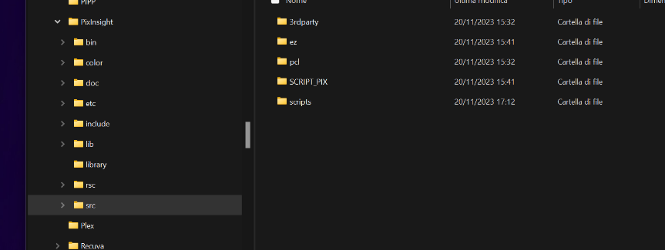
The external scripts that you want to add are first saved in the Program Files folder – Pixinsight – in the SRC folder then, once you open Pixinsight, you enter Scripts – Feature Scripts and use the Add button to identify the path where they have been placed and select their folder. Once you have chosen "Select folder", press the Done key and the window closes, Pixinsight processes them and from that moment they are available.

External processes
External Processes are added by copying the files constituting the new process into the Pixinsight "Bin" folder.
Then enter Pixinsight and from the Process label choose the item "Modules" "Install Modules"
Click "Search", the module to be installed will be located, choose it and click "Install".
From this moment, when you open Pixinsight again, they are available.

Label laterali Pixinsight
The side labels are:
- Process Control (opens already used processes) –
- View Explorer –
- Process Explorer –
- Format Explorer
- History Explorer –
- File Explorer

LIBRARIES FOR PIXINSIGHT

GAIA Bookcase
Scaricare i file da Pixinsight: https://pixinsight.com/downloads/index.html
- Arrange the files in specific directories e.g. "Gaia DR3 SP complet set"
- Start Pixinsight and open the Gaia process
  - Located in Process <All Process> Gaia
- Click on the wrench icon from the drop-down menu choose the Gaia version you want to install
- Press the "Select" button indicate the path where the relevant files are stored Select them all
- Press OK to save the indicated path

APASS Bookcase
Scaricare i file da Pixinsight: https://pixinsight.com/downloads/index.html
- Arrange the files in specific directories e.g. "Apas"
- Start Pixinsight and open the APASS process
  - Located in Process <All Process> APASS
- Click on the wrench icon from the drop-down menu choose the Gaia version you want to install
- Press the "Select" button indicate the path where the relevant files are stored Select them all
- Press OK to save the indicated path

MARS (Multiscale All-Sky Reference Survey)
MARS is a new project for additive gradient correction in astronomical images of the deep sky based on observational data. It will be the basis of the next generation of gradient correction algorithms and tools in PixInsight.
To date, gradient correction is achieved with a simple assumption. We define a gradient model by recognizing the areas within the image that should be free of extended objects. But these techniques are completely subjective.
This technique uses both narrowband and wideband recordings to generate the surface brightness map that the gradient correction tools will access so that you don't have to guess where the sky background is in the image. Correction is done by simply comparing wide-field and narrow-field images.
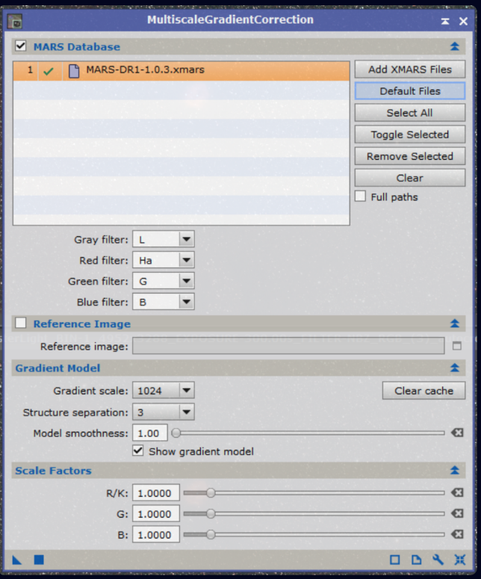
Scaricare i file da Pixinsight: https://pixinsight.com/downloads/index.html
Arrange the files in specific directories e.g. "MARS" together with the other star libraries
Start Pixinsight and open the MGC: Multiscale Gradient Correction process
Si trova in Process Multiscale Processing Multiscale Gradient Correction
Click on the wrench icon from the drop-down menu to add the file you want to install
Press the "Select" button indicate the path where the relevant files are stored Select them all
Press OK to save the indicated path
Whenever you want to use these files, simply hit "Default Files"

CREATE PIXEL_MATH PROCESS
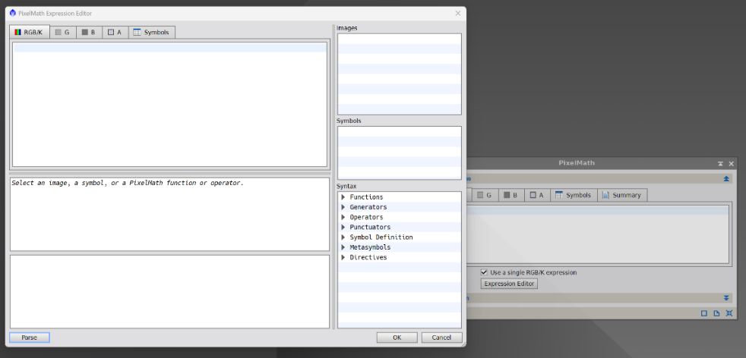
To create a process in Pixel_Math you need to open it and insert appropriate formulas in the different Labels.
To create HT_Stretch_Linked_RGB, for example, you have to open Pixel_Math and click on "Expression Editor"

A window opens where you can go to enter the formulas: in the "RGB/K" label copy/paste the following text as written below:

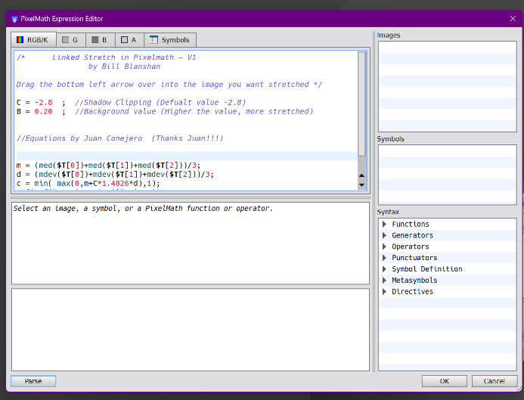
/* Linked Stretch in Pixelmath - V1 by Bill Blanshan

Drag the bottom left arrow over into the image you want stretched */

C = -2.8 ; //Shadow Clipping (Defualt value -2.8)
B = 0.20 ; //Background value (Higher the value, more stretched)
//Equations by Juan Conejero (Thanks Juan!!!)
m = (med($T[0])+med($T[1])+med($T[2]))/3;
d = (mdev($T[0])+mdev($T[1])+mdev($T[2]))/3;
c = min( max(0,m+C*1.4826*d),1);

mtf(mtf(B,m-c),max(0,($T-c)/~c))
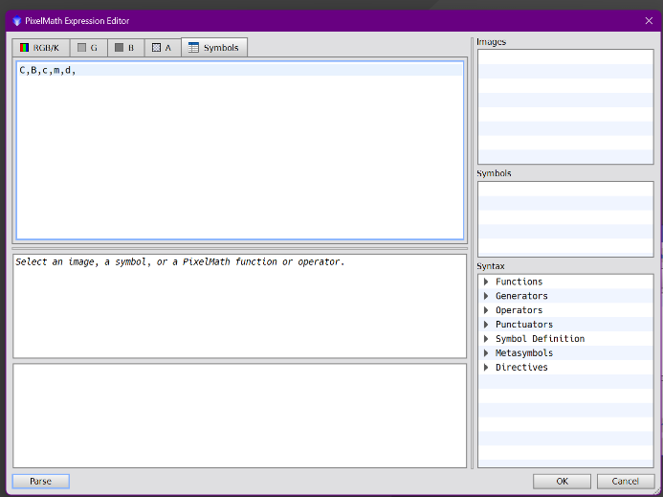

In the "Symbols" Label, copy/paste the following text as written here:
C,B,c,m,d,

Give OK
The window closes and the formula is ready.
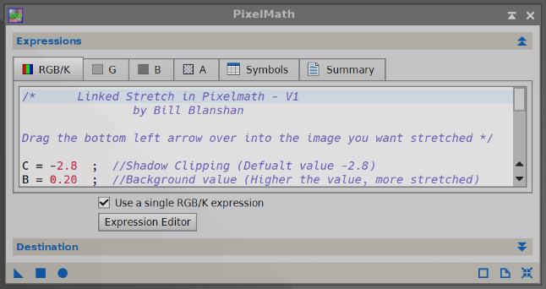

To save it, drag the blue triangle on the Pixinsight board and name the function by clicking on N (Name)
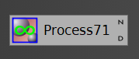
Saving the Project keeps the icon available for future use

Export Job Pixel_Math
To export a process, you need to have the icon on the Pixinsight whiteboard. Select it and use the right mouse button to choose "Save selected icons". Choose the path where you want to save Save

HOW TO CREATE LOCAL MASKS WITH PIXINSIGHT https://www.youtube.com/watch?v=z3OBjQ3iUHw

Create luminance mask of stars
With Histogram Transformation darken the background of the luminance do not worry about losing details, important is that the stars, the subject, must remain while the background must become uniformly black, otherwise the star mask will not respond well.
Duplicate the luminance mask
Open the Star Mask process and do "reset" to make all parameters default
Enlarge the cloned luminance image Point at the smaller, fainter stars and see their K value
Noise threshold Indicate the value read This tells Star Mask that values below that value are noise
Stairs leave 5
Large Scale abbassare a 1
Apply with blue triangle on the image

Apply the Star Mask obtained to the luminance image and invert the mask to notice any stars that have remained white these have not been covered by the signal In this case delete the Range Mask and redo it
Noise threshold raise the value a little
Scales If bright stars remain uncovered, raise the value, e.g. bring to 7
Reapply the process

Apply the resulting Star Mask to the luminance image and invert the mask to notice that all the stars are red, i.e. the stars in the galaxy have also been included If ok, remove and keep the Star Mask from the luminance image created

Create a black / white image
Open Pixel Math Reset
RGB/K 1 (writing 0 would make the image black)
Destination Create new image
Image ID “Bianco”
Apply with a Blue square to form a completely white image

GAME
It is used in particular to eliminate deep-sky chrominance errors
Aprire lo script Game
Si trova in Script > Utilities > Game
A window opens from which you can:
- choose whether to start from an Ellipses an ellipse is formed that I can then modify
- creating Multi points by manually choosing points to create a shape that I can then modify
- Click on +add to create a first ellipse shape in the preview
- Multi point Click on +add to create the first point in the preview to drag to create the desired area. Starting from the red dot, add as many points as you like that can be dragged to form the desired area
- Drag the blue dots to give the desired size
- Drag the red dot to move the shape to the desired area
You can also create multiple shapes on the same preview
- Write shapes to Files/Views Apply shapes from the hard outline to the image of my choice
- Export Masks I choose the type of mask I want
Giving the OK Create the mask to be applied
With the Convolution process I can still soften the created mask, as if it were a MaskBlur
It is used in particular to eliminate deep-sky chrominance errors
Applying the mask on the image to protect the subject
Apply a very light Convolution, all the colored points are blended and the situation improves

EXPLANATION OF AESTHETIC DEFECTS
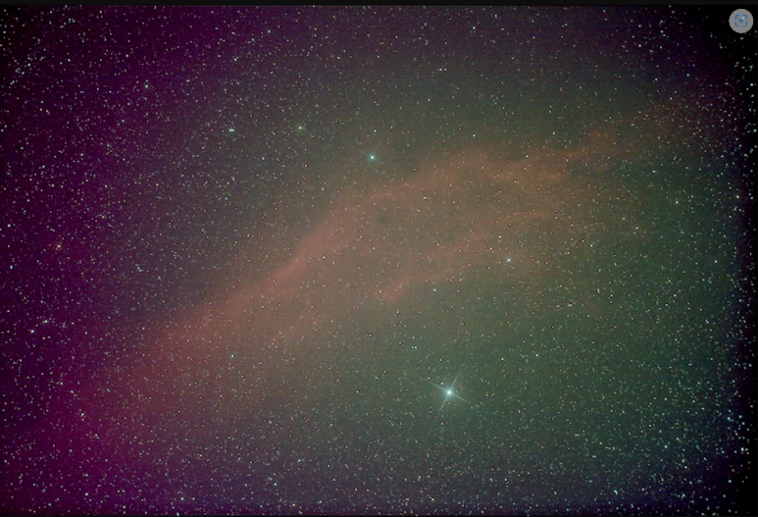
In this image you can clearly see 2 typical defects: the vignette and the gradient (there are others but let's forget :D ).
The vignetting is well noticeable as a drop in brightness at the edges and can be corrected well with the flat. I would say that it is a defect in brightness, it decreases as you get closer to the edges of the frame.
The gradient: as you can see, the right part of the frame tends to green and the left to magenta. In this case it is more a problem of chrominance, it is not a variation in brightness but a difference in the color tone of the frame. This is not eliminated with the flat. In this photo the two defects are added together (vignetting and gradient). These defects are highlighted by the processing processes (stretching and the like), in the single frame they are not very evident.
For light pollution that leaves gradients and noise on the sky background, you can try to intervene through Histogram Transformation which cuts the darks a little more with the help of the live preview.

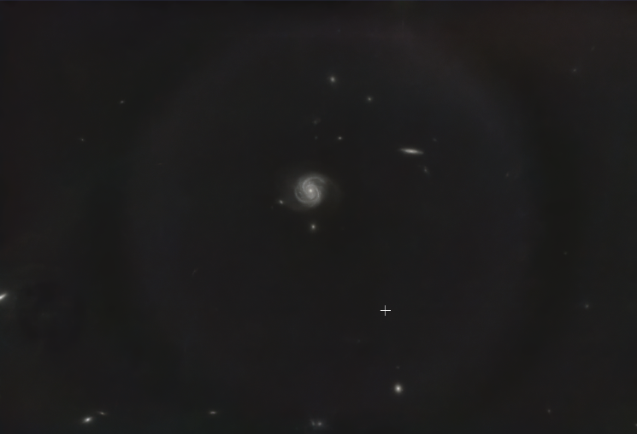
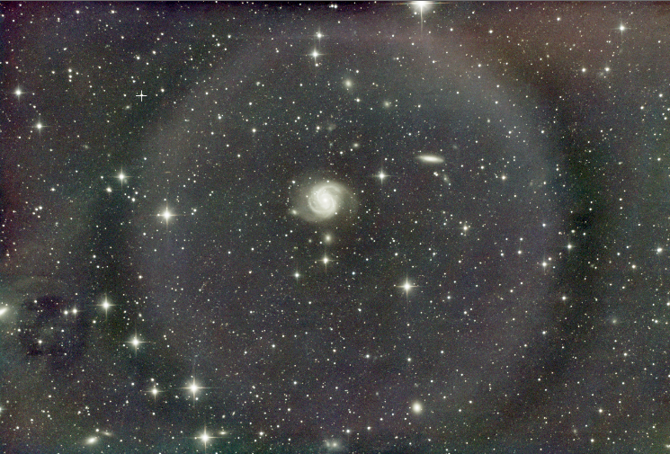
In these photos there is the presence of a halo all around the subject that can degenerate with processing. The Flats have not been able to remedy sufficiently. This defect can originate from various causes, the last but not least the reflections inside the telescope.

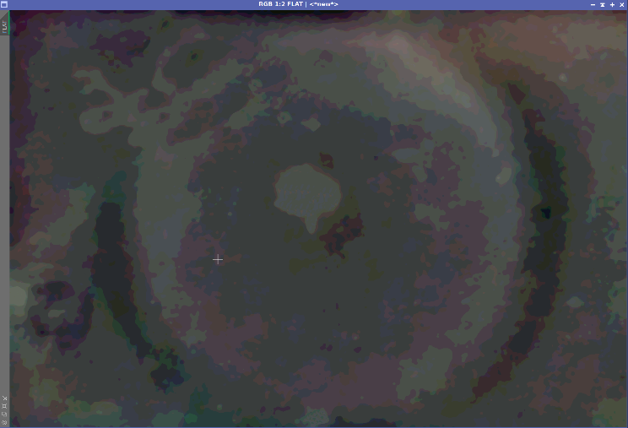
For this defect it is necessary to understand and intervene on the cause, but in the meantime, if the subject is well defined and simple, e.g. galaxies or clusters, you can try to solve the problem through a Synthetic Flat, as explained in a specific paragraph.

The synthetic Flat is called such because it is generated from the image with the defects and through PixelMath the integrated image is manually calibrated by means of this.

Another defect that can be found is the so-called "walking noise". It appears as vertical or diagonal stripes, they are patterns of electronic noise that overlap coherently between the various shots.
The main cause is the absence or ineffective setting of dithering, combined with a slight shift (drift) of the frame between the poses. This defect is prevented via software during capture.

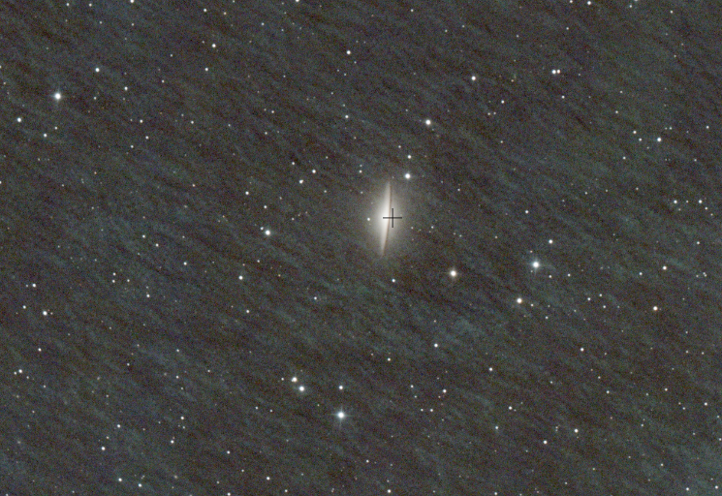
Dithering consists of slightly shifting the frame between one shot and another in very small movements: a few pixels, so each image taken will have the stars in almost the same position, but the sensor registers the noise in different points.
With dithering the defects move between the different images and stacking recognizes them as "not real" by eliminating them much better. The final result after stacking will be a cleaner and more detailed image, with less noise, no strange "patterns".
As for the dithering setting parameters, there are no precise rules, but indicatively you can set a dithering according to these criteria:

Pixels: this parameter defines the limit of random movement in direction and distance, a higher value corresponds to a considerable amount of movement between one photo and another. If you set a low value (e.g. 1 or 2 pixels) the camera may not move enough. A value of 5 or 10 is therefore better
Interval: defines how many images it should dithering. This value can be chosen as a function of the exposure time according to the following table:
Exposure | Recommended dithering
30–60s | every 2–3 frames
120–180s | every 1–2 frames
300s+ | Each frame

Now let's move on to the stability setting of the guide. Stability and settling time must be set correctly, they check how the system corrects the errors of the mount: The guide camera observes a star, the software sees if it moves and sends corrections to the mount trying to keep it still in position.

Stability: this is the error threshold below which the guide must fall to be considered "stable". Stability 2.0" indicates 2 arcseconds of angular error of the sky; the symbol " does not indicate seconds but arcseconds (1° = 3600 arcsec).
Indicates that the mount must have an error of less than 2 RMS arcseconds before it is considered stable. This means that the lower the value you set, the more accurate you want the guide to be, but you will also have to wait longer before you can take the next photo.
Settle Time: is the time that the guide must evaluate at these values in arcseconds to be considered stable.
Together they mean: "I only shoot when the error is below 2 arcsec for at least 5 seconds"
Timeout: is the maximum waiting time for the guide to stabilize, it answers the question: "How long maximum do I wait for the guide to become stable again after dithering" and the shots can continue

Practical example: after dithering, the guide gets high
- The system tries to stabilize and drops below 2.0" and remains stable 5s
- The system fails to stabilize and maybe remains at 2.5" / 3" the system continues to wait until it reaches the Timeout then resumes shooting

Aggression (RA Aggr / DEC Aggr) indicate how strong to correct the mistake:
100% = fixes everything right away
50% = correct half of the error
If the value is too high → we have adjustment oscillations (ping-pong effect)
If the value is too low, → slowly chases → moved stars
For example, RA Aggr 60–80% and DEC Aggr 70–100% can be tried as initial values, but they are not universal. They must be adapted to the mount, backlash, seeing, driving interval and actual autoguiding behavior.

Note: Vedere https://www.youtube.com/watch?v=eFS1tOT0jy4&t=575s

CREATE CUSTOM FILTERS FOR SPCC
If the sensor, camera, or filter filter is not provided in the standard Pixinsight database, you need to search the internet in . CSV files or create it from scratch and add it to existing ones.

I found the CSV files here: https://onedrive.live.com/?redeem=aHR0cHM6Ly8xZHJ2Lm1zL3UvcyFBajRvT2tqNlFJaFprN2dVQUQtRHpKUGxXT0I0cFE%5FZT1XOW94Y3U&id=598840FA483A283E%21318484&cid=598840FA483A283E

To create your custom filter (https://www.youtube.com/watch?v=vGzEcrfVcmE&t=1302s)
https://youtu.be/bAwK5Isk-U8
Obtain a jpg or png image with a maximum size of 1700 x 1200 pix, of the graph of the response in efficiency of the filter, (or of the quantum efficiency of the camera) that you want to create
Go to the "graphreader.com" website http://graphreader.com/
Here, after loading the image of a graph and tracing some points, the program interpolates them and produces the series of wavelength and transparency pairs both in CSV and in JSON

Note: For a color camera, quantum efficiency is actually the combination of quantum efficiency + the filter so we treat it as if it were the filter on a monochrome camera with ideal EQ
Note: PAN filters do not appear in the choice of Red Green and Blue filters but only in Filter Manager > Curve Explorer to create the camera + filter
Note: White references cannot be exported/imported.

Uploaded GO image
Once the image is loaded, I stretch the corners of the blue box adapting it as accurately as possible to the size of the graph
In the lower part I define the axes:
- Y-low is always 0
- y-high is always 1 even if the chart has a different range
- Instead, I set the x-low and x-hight nanometers as a function of the image
- For X-axis stepsize, considering that Gaia has filters with steps of 2 nanometers, we would be fine with 1, but the site is limited to 500 stepsize so if I have to do for example from 400 nanometers to 1000 which are 600 putting 1 I don't fit in, so I agree to put 2
Now I double-click on the curve of interest, for example the blue curve, tracing the curve as faithfully as possible, thus creating fix-points. A single click with the right mouse button deletes the marked point.
Now click on Generate curves : the program calculates the points and redraws the numbers of the sampled curve: in the first box I find the fix-points marked manually and in the second box the Sampled values, transparency curves generated by reading the graph.
In Curve Sampling I choose Linear interpolation
I choose to get the JSON values of each box (just click on a JSON to get both) the x and y axis values are shown on the screen.

I open a text file with the notepad that I will call with the name of the filtro.csv and write:
- type, "filter" even if we are working on the graph of the quantum efficiency of a camera
- name, "ASI 294 custom R" (example value)
- channel, "R" (example value, for light pollution filters it is "PAN", for cameras it is "Q" Quantum Efficiency)
- default, "B" (line that can be omitted to write default tells SPCC to always present these filters by default)
- wavwlenghth, "nnnn" copy/paste of the X numbers obtained from the software: the wavelengths, but without square brackets and paste them in quotation marks
- transmission, "nnnn" copy/paste of the X numbers obtained from the software: the wavelengths, but without square brackets and paste them in quotation marks
At this point File Save as e.g. ASI 294 custom R save in a special folder

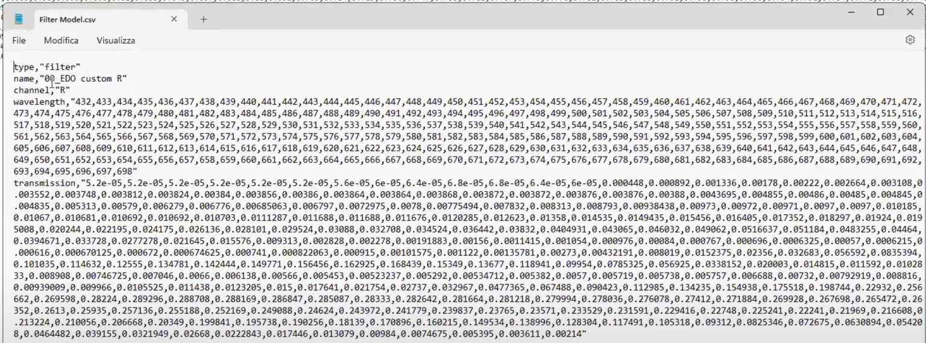
I do the same thing with the curve of a filter, stretching the corners of the blue box up to a useful area, not necessarily to the bottom, it is important to shoot the peaks well.
With Clear fix-points I delete all the points on the curve but I don't delete the graph being processed, so I can switch to another color of the same graph.

At this point, save the files created all in a folder, Pixinsight will load all the files in it. The files are readable and editable with the simple Notepad.

In order not to jeopardize the original Pixinsight database, if not already done it is best to make a backup copy:
Pixinsight Process Spectrophotometry Filter Management
- Task: Export CSV filter definitions
- Directory output: Indicate a destination folder, e.g. "Original filters /CSV" the blue dot starts the export
I also export the XML database to a folder:
- Task: Export XML filters database
- Directory output: Indicate a destination folder, e.g. "Original filters"
- Enter the name of the destination file, e.g. "Original Spectrum DBs" Save the blue dot Start the export of the file "Original Spectrum DBs.xspd"

Now I can upload the files created:
Pixinsight Process Spectrophotometry Filter Management
- Task: Merge CSV filter definitions
- File or directory: Indicate the folder where the personal CSV files to be added are saved
The blue dot starts the Merge that adds our files to the default ones

If you want to make the custom database the default, first you need to save the new updated database:
Pixinsight Process Spectrophotometry Filter Management
- Task: Export CSV filter definitions
- Directory output: Indicate a destination folder, e.g. "Personal Filters 2026/CSV" the blue dot starts the export
I also export the XML database to a folder:
- Task: Export XML filters database
- Directory Output: Indicate a destination folder, e.g. "Personal Filters 2026"
- Enter the name of the destination file, e.g. "DB Spectrum personalized" Save the blue dot starts the export of the file "DB Spectrum original.xspd"
Then tell Pixinsighit the new route:
Pixinsight Edit Global Preferences Core Filters
- Default Filters Database Select Indicate the updated file
The blue dot defines the new customized filter package by default

DEFINE THE USE OF CUSTOM FILTERS FOR SPCC
The use of custom filters can improve the correctness of color calibration when the response curve of the filter and sensor is correctly represented. However, it does not guarantee perfect balance on its own: the quality of the model depends on the correctness of the data used to describe the optical system.
This is accomplished by Pixinsight's Process Filter Manager
Si trova in Process > Spectrophotometry > Filter Manager
In order not to jeopardize the original database, if not already done it is better to make a backup copy. As explained in the previous paragraph.

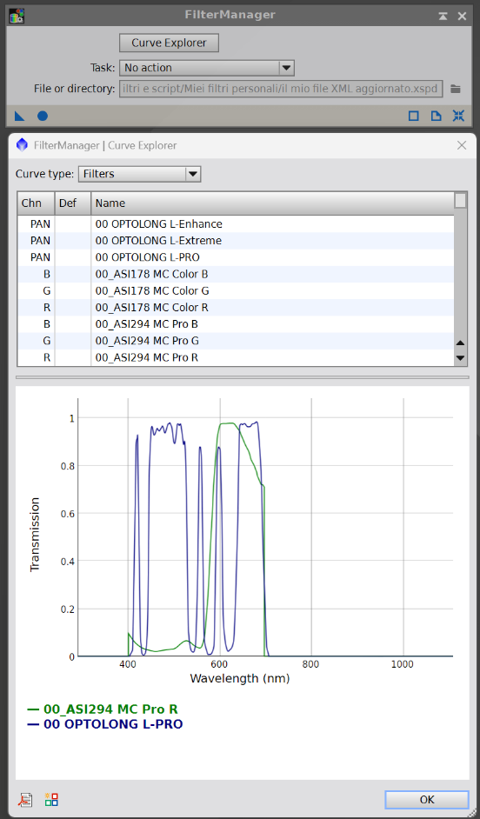
At this point in the Filter Manager I can move on to define the custom filter:
- Task: No action
Click on the curves Explorer, a list opens with all the available curves:
- Choose the camera filter as the first filter: e.g. Sony Color Sensor R (then we will do the G and B filters)
- Press CRL button and at the same time choose the second filter e.g. Optolong L-Pro
- Click on the Combine icon is located at the bottom left, consisting of colored squares
- Naming the new filter set (e.g. 00_eos400D L-Pro B 00 puts it at the top of the list)
- Assign a Filter channel: e.g. R (then we will do the G and B filters)
- Give OK and OK again
- Confirm to Save
In order to always have the personal filters defined in the future, with the same method described above, you must make the custom database the default solution:
Pixinsight Process Spectrophotometry Filter Management
- Task: Merge with default filters
The blue dot defines the new customized filter package by default
Sony Color Sensor R + IDAS NGS1
As a precaution, I export the new updated database to an external folder
- Task: Export XML filters database
- File output: Indicate the folder where we want to save the custom database
The xspd file is created with the blue dot. The files are readable and editable with the simple Notepad.
- Task: Return the Task to "No action"

MULTICHANNEL RESOURCES
The techniques described can also be used with OSC cameras, although the treatment of channels and filters is different from that of a monochrome camera with separate filters. Some workflows are more natural with a mono camera, but are not unique to it.

ISO to Gain for Cameras

For NEF (Nikon RAW) files, the gain is not explicitly stored as it is for many astronomical cameras (ZWO, QHY, etc.). In Nikon NEFs, the available parameter is the ISO, while the real gain of the sensor is implicit and depends on the camera model.
So: to find the gain you need to know the ISO → and⁻/ADU curve of the specific Nikon sensor.

For the Nikon D850 ( BSI CMOS sensor 45.7 MP Sony IMX309, 14 bit) we have pretty solid data from independent tests (RawDigger, PhotonsToPhotos).
Below you will find real gain, reading noise and recommended ISO, with astrophotographic reference.

Nikon D850 – Gain Reel (E⁻/ADU)
⚠️ In NEFs , the gain is not written: these values are derived from reliable experimental measurements.
📊 ISO → Gain Table
ISO | Gain (e⁻/ADU) | Read noise (e⁻)
64 | ~0.45 | ~3.2
100 | ~0.70 | ~3.0
200 | ~1.40 | ~2.7
400 | ~2.80 | ~2.5
800 | ~5.60 | ~2.3
1600 | ~11.2 | ~2.3
3200 | ~22.4 | ~2.3
6400 | ~44.8 | ~2.3

For the Nikon Z6 II (full-frame BSI CMOS sensor 24.5 MP Sony, 14 bit) the data are well known thanks to RawDigger / PhotonsToPhotos measurements. Here too the gain is not written in the NEFs, but is obtained experimentally.

📷 Nikon Z6 II – True Gain (e⁻/ADU)
📊 ISO → Gain Table
ISO | Gain (e⁻/ADU) | Read noise (e⁻)
100 | ~0.80 | ~3.3
200 | ~1.60 | ~3.0
400 | ~3.20 | ~2.0
800 | ~6.40 | ~1.9
1600 | ~12.8 | ~1.9
3200 | ~25.6 | ~1.9
6400 | ~51.2 | ~1.9

Sources and references
For the drafting of this document, in addition to the personal experience and explanations received from Alberto Airola, information and reference materials from various sources available online, including Wikipedia, specialized sites and video content published on YouTube, have been used.
The information has been edited and organized by the author within his own processing method. The contents and materials belonging to the respective authors remain their property.

